INTRODUCTION

Marine problems are of national importance• At the pres­ent time, the U# S* Government is stimulating interest in marine activities in many areas. Examples of problems receiving attention are shore erosion, harbor protection, sea-water intrusion of the fresh-water table, navigation, underwater transportation, oceano­graphic exploration, hydrofoil ships, nuclear-powered vessels, ice­berg movements, seafood, pollution control, etc* One program which has gained national and international interest is that of the Office of Saline Water to develop methods of converting sea or brackish water to fresh water.

For highly saline waters, such as sea water and brines from salt wells, many today favor distillation processes as the most economical method of producing potable water* Processes which can make use of waste heat (often available at shore-based steam plants, at refineries, and at chemical plants) are particularly attractive.

Some of the thermal processes under investigation by the Office of Saline Water include conventional distillation, distilla­tion using Yapor-compression multi-stage flash evaporators, distil­lation with vapor reheat, distillation without the use of metallic heating surfaces, vapor compression using forced circulation, etc.

This increased activity in the utilization of sea water involves the use of a variety of equipment and focuses attention on the need for knowledge of the behavior of metals and other materials in marine service.

Before choosing metals or other materials of construction for distillation plants handling sea water, many factors have to be considered. Among these are the intial cost of materials, the efficiency of the materials in the intended design, the lifetime of these materials as influenced by corrosion and by other factors, and the amount of servicing required to keep the intended design opera­tional.

The chemistry of sea water is complex and much more in­formation needs to be developed. Many materials behave unpredict- ably in sea water, particularly when incorporated into actual designs. This report is concerned primarily with the corrosion behavior of metals and other materials in sea water, in diluted sea water, and in brackish waters. Corrosion and scaling problems as a result of heating saline waters are given particular attention.

Information presented was obtained from (1) a review of pertinent corrosion literature, (2) consultations with experts in

the field of corrosion, (3) reports of marine corrosion research, presented at meetings of The Sea Horse Institute (directed by The International Nickel Company) at Wrightsville Beach, North Carolina, (私）manufacturers1 technical publications, and (5) Battelle*s own marine experience.

CORROSIVITY OF SALINE WATER

The Nature of Corrosion

Aqueous corrosion is known to be electrochemical in nature* A simplified concept of the corrosion mechanism proposes anodic and cathodic areas on the metal surfaces. At the anodes, the atoms of the metal release electrons, become positively charged ions, and enter the solution. The electrons pass through the metal to the cathodic area where they discharge a positive ion, often hydrogen. Thus the process involves a flow of electrons through the metal and a flow of charged ions through the solution or electrolyte. The electrical currents which cause corrosion are modified by polariza­tion at the electrodest by the formation of passivating films, by scale formation, by local variations in concentration of soluble materials in the electrolyte, and by a number of other complicating effects.

The following paragraphs outline the major factors which influence corrosion reactions. Since their inter-relationship is quite complicated, it can be seen that no use of them can be con­sidered 6〇lely in analyzing a given situation^ However, they are discussed individually for clarity*

Natural sea water differs from synthetic sea water’ from the corrosion standpoint, mainly because of the effects of the living organisms present in the ocean. For this reason, it is most desir­able to use natural sea water in conducting corrosion experiments at normal temperatures* Howevert since the organisms are killed by heat in the distillation process, their effect is not important in corrosion at elevated temperatures.

Much useful information has been developed from work done in the laboratory with saline solutions made up to simulate sea water with respect to its inorganic constituents. Hachs^^has, for example, carried out some very interesting experiments concerning the corrosion of iron in sodium chloride solutions. Such experi­ments provide information which has a direct and useful bearing on natural sea-water corrosion problems.

Corrosive Ions in Sea Water

The chloride ion is probably the most deleterious ionic constituent occurring in sea water in large quantities* Its corro­sive nature comes from the fact that it readily penetrates passive protective films and thus enhances the corrosion reactions.

In addition to chloride ions, the anions found to the greatest extent in sea water are sulfate« bromide9 fluoride, and bicarbonate. Lyman and Abel(2)list a typical analysis for the major constituents of a sample of•North Pacific Ocean water# Their data, tabulated below, also include the major cations present*

|  |  |  |  |
| --- | --- | --- | --- |
| Cations | per cent | Anions | per cent |
| Na+ | 1.056 | ci- | 1*898 |
|  | 0.127 | scv | 0.265 |
| Ca++ | 0.040 | HCO3- | 0.0X4 |
| K+ | 0.038 | Br_ | 0.0065 |
| Sr— | 0.001 | F 一 | 0*0001 |
| Sum: | 1.262 | Sum: | 2.184 |
|  |  | undissociated) | .003 |

Grand Total: 5•缽谷9 per cent

Natural processes, operating both at the surface and at great depths, result in a continuous circulation of ocean water, so that the relative proportions of dissolved salts are virtually the same everywhere, although the total salt content (salinity) may show appreciable variations with geography•

The halogen ions, other than chloride, are present only in small amounts, and their corrosive effects in sea water are probably masked by the very high chloride content.

Other corrosion experience would suggest that the sulfate also contributes much less to the corrosion by sea water than the chloride.

The presence of bicarbonate ions in water can help promote corrosion attack on many metals.

Tt should be mentioned that the vE of sea water normally

Since corrosion is dependent on electrolytic processes, it is greatly influenced by the conductivity of the solution. Sea water is a good electrolyte, so it is not surprising that it is corrosive# Fig­ure l〇)shows that the resistivity of sea water is relatively low at normal temperatures. However, it can also be seen that as the water is diluted (as might occur near rivers), the resistivity is markedly in­creased. Accordingly, the corrosion might be expected to be somewhat less in the vicinity of rivers. Actually, the effect of varying the salinity is inter-related with some of the other variables, as far as corrosion is concerned. For example', concentrating sea water (as in a multiple-effect distillation process) reduces the oxygen solubility.

For steel and for the temperatures involved in a typical process, it is found that the rate of attack becomes less as the brine becomes more concentrated. The role of oxygen is discussed more completely later.

It is interesting to note that resistivity for sea water in the normal range of salinity is not greatly affected by temperature (see the lower curve in Figure 2)* On the other hand, a solution of only 1*84 parts/thousand (0/00) salinity decreases almost one half in resistivity as the temperature is increased from 32. to 77 F,

Oxygen and Temperature

Of the environmental factors, oxygen ranks high in degree of importance. It affects corrosion reactions by depolarizing cathodic areas, by oxidizing ferrous compounds, and by changing cell potentials.

An increase in temperature normally can be expected to speed a chemical reaction so that corrosion could be expected to accelerate as the temperature is increased. Since oxygen content and temperature are related, the individual effect of each is difficult to differenti­ate.

According to Speller(4)， when steel is heated in ordinary water at a constant oxygen content the corrosion rate increases with temperature in the range 100 to 3〇〇 F, If the oxygen is allowed to reach its normal saturation level, the corrosion reaches a maximum at about 175 F and decreases with increasing temperature above that point because of the decrease in oxygen solubility. The oxygen level in sea water can vary from low to relatively high concentrations (0 to 12 ppm)(为）• For example, photosynthesis in green plants in the water tends to increase the amount of oxygen in solution. Wave action and spray formation tends to maintain the water near the surface approxi­mately saturated with oxygen. On the other hand, the activities of bacteria in polluted water may result in lower oxygen content and an increase in carbon dioxide and, at the same time, cause the presence of hydrogen sulfide. The surface water at the tropics, because of the elevated temperature, may have only half as much oxygen present as for Arctic waters.

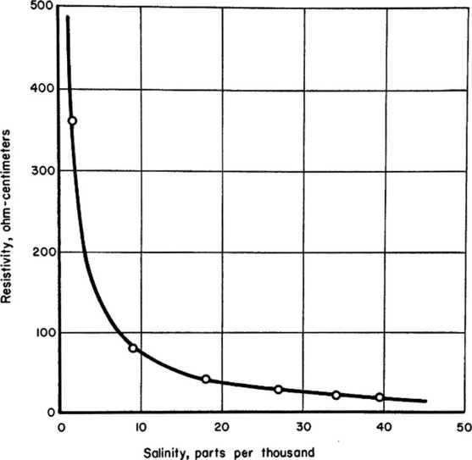

FIGURE I. CHANGE IN RESISTIVITY WITH SALINITY AT 59 F

/>iai9UUJICa>o-£L10 *A.t:>l(n!sa>a:

4

2'

K

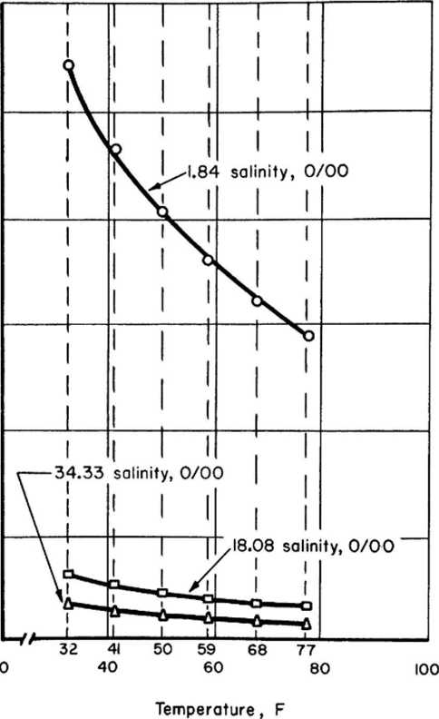

FIGURE 2.

CHANGE IN RESISTIVITY WITH TEMPERATURE AND SALINITY FOR SEA WATER

No systematic investigation has been made correlating corrosion with the oxygen content of sea water. However, several research workers have reported results in this area for steel in salt solutions and the general conclusions can probably be applied to sea water.

The corrosion behavior of iron and the oxygen solubility as a function of the salinity of the solution at 75 as reported by Hache(l), is illustrated in Figure 3. It is to be seen that sodium chloride does not affect the solubility of oxygen in water until a concentration of almost 10 g/liter (about 1 per cent) is reached* From that point on, the oxygen solubility decreases with increased salt content and approaches 1 ppm at 360 g NaCl/liter.

The curves also show that a corresponding decrease in corrosion rate follows the decrease in oxygen content.

The oxygen solubility in chloride solutions and the cor­responding corrosion rate of a steel coupon as studied in another laboratory(5)are shov/n in Figure 知. It can be seen, as was just pointed out, that the dissolved oxygon content is significantly de­creased by an increase in salinity* In general, the values are slightly lower than those presented in Figure 3.

The corrosion rate of steel (in this short-time test) reached a maxinura in about 1 per cent of codium chloride. This cor­responds to the highest oxygen concentration studied. At higher salt contents, the reduced oxygen content of the solution resulted in a reduction in the rate of attack* This reduction varied directly with the oxygen content.

Figure 5 shows the effect of temperature on the corrosion of iron by air-saturated and partially deaerated solutions containing 3〇 g/liter of sodium chloride• As might be expected, the corrosion increased with an increase in temperature. At the lower temperature studied, the aerated solution contained about four times as much oxy- gen as the partially deaerated solution and was about three times as corrosive• At about l4〇 F in this open system, the oxygen contents were about the same and the corrosion rates were identical. A simi­lar temperature dependence had been, reported earlier by Palmaer^).

At ordinary temperatures, practical experience has shown that steel will resist saline waters if essentially all of the oxygen is removed. Not much quantitative information is available about the behavior of steel in saline waters at elevated temperatures free from oxygen* However, some related experience seems to be significant•

In certain oil-field secondary-recovery operations, brines (some containing the same salts as in sea water) are pumped to the surface and reintroduced at another point into the formation. Ex­perience has shown that these brinesf which may be at temperatures of 200 F or above, can be handled in steel equipment such as pumps, valvest piping, and other fittings. Satisfactory lifetime is exper­ienced if no oxygen is allowed to mix with the brine solution in this closed system. Slight air leakage can be compensated for by

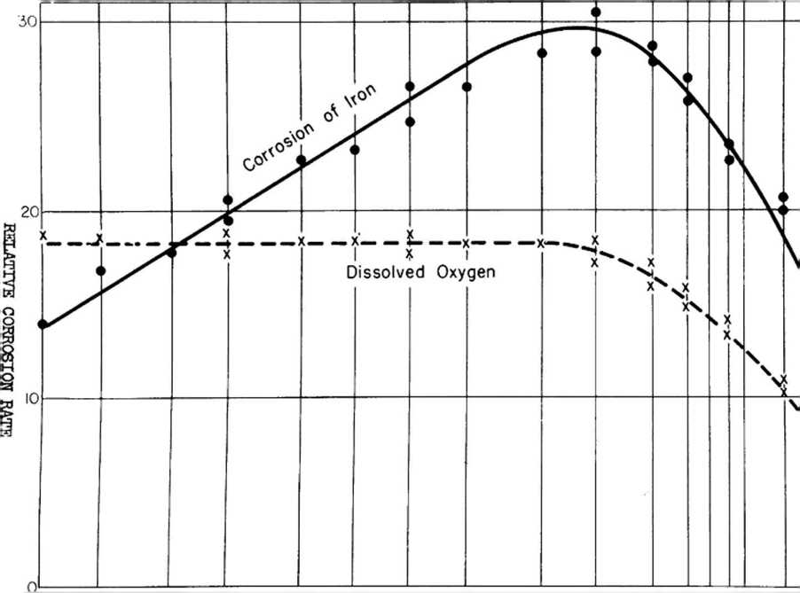

0.02 0.05 0.1 0.25 0.50 I 2 5 10 20 30 50 60 100

FIGURE 3. VARIATION OF CORROSION OF IRON AS A FUNCTION OF THE SALINITY, Adapted from Reference I

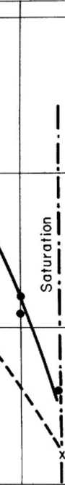

OXYGEN,曰卯 per 1

I5I4I3I2ZII0987 6 5 4 3 2

Sodium Chloride, g per l

AD-Diad SHE *94D(rUOISOJJOO

.68

4

4*

6

.9

0•

d

8

.4

0.

I

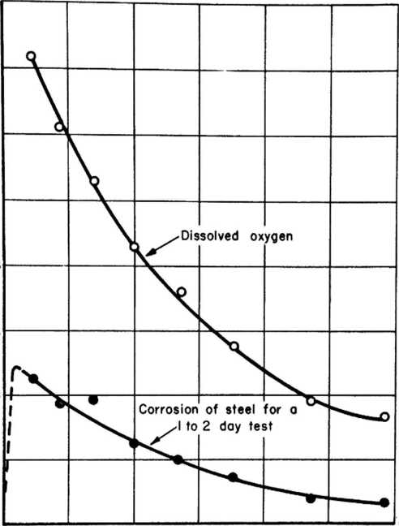

0 5 10 15 20 25 30

Edd *uoj_DJ4usuoo U&AXO*oaAIOSQ

NaCI Concentration, per cent, at 77 F

FIGURE 4. CORROSION OF STEEL AND OXYGEN SOLJBILITY AT VARIOUS No Cl CONCENTRATIONS



和 sa>一 JM(Dl/o>aicOJI psosso

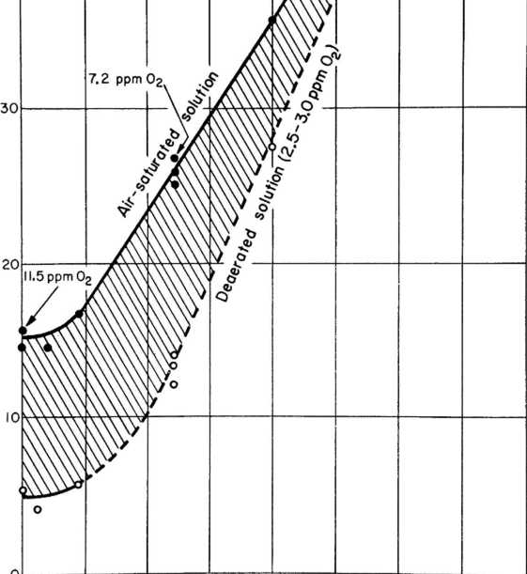

32 50 68 86 104 122 140 158 176

Temperature, F

FIGURE 5. CORROSION OF IRON IN 3% No Cl SOLUTION SHOWING THE EFFECT OF TEMPERATURE

cases, it is desirable to add a small amount of a corrosion inhibitor to the brine*

At The Sea Horse Institute, it has been observed that steel immersed in sea water at the 86 to 9〇 F summer temperatures corrodes at about 5〇 per cent faster rate than at the 4〇 to ^5 F winter temperatures.

The effect of temperature on the corrosion of brass has been studied. For example, red brass and Naval brass are com- pared in a 10.8 per cent sodium chloride solution, see Figure 6、 •

Both materials Bhow higher rates of attack with increase in temperature. The Naval brass (6〇Cu-392n-ISn), which shows the highest rates of the two materials, is not presently considered a preferred metal of construction for saline v/aters. Although not given in the reference, one would expect dezincification attack on the Naval brass in heated chloride solutions.

Admiralty brass is a widely used metal in brack­ish water and sea water. It shows, in another experiment, greatly accelerated deposit attack as the temperature is in­creased (see Figure 7)• A 3 per cent sodium chloride solution was used as the corrodent, and cotton wads were placed on the metal surface to simulate deposits.

It should be noted that the corrosion for the above metals is much different from that for steel in that there is no indication of a decrease in corrosion rate at elevated tem­peratures as oxygen is lost from solution.

Velocity

Oxygen-saturated sea water at the surface of the metal tends to increase the over-all corrosion reaction in most cases. However, in a few instances, oxygen is necessary to promote the formation of desired protective films. If a critical velocity of flowing s©a water is exceeded, the protective film may be eroded away. For example, the inlet ends of condenser tubes are fre­quently attacked (see Figure 10). Jet tests have been devised for ranking the susceptibility of metals to such impingement atta,cl£. The maximum velocity for useful corrosion resistance is low for copper (2 to 3 ft/second); higher for aluminum, cupro nickels, and aluminum bronzes; relatively high for stainless steels and Hastel- loy C; and highest for titanium (20 to 5〇 ft/second)♦

Cavitation is caused by the repeated pounding on the metal, resulting from the rapid collapso of vapor bubbles in the water* Where there is violent flow of the water, such as that of a ship propeller at high speeds, the pressure at some area on the metal surface may be reduced so that localized boiling forms bub­bles of vapor. At another site, vihen these bubbles suddenly col­lapse, the resultant hammering may in time cause a layer at the surface to fail by repeated compression, allowing pieces of metal to flake off. The active metal exposed may, in turn, be rapidly attacked by exposure to the sea v/ater. It has been found diffi­cult to develop a laboratory test that will accurately simulate cavitation attack as it occurs in actual marine service.

Heat Transfer

With heat being transferred through the metal surface, there is a boundary film of sea water next to the metal surface which may be much hotter and, therefore, different in composition and behavior from the bulk solution. Scale, because of reduced solubility in this film, can be expected to deposit on the metal and interfere with the corrosion attack.

Stress

Some metals, particularly the stainless steels, are very susceptible to stress corrosion and corrosion fatigue in sea water. It is generally good practice to minimize surface tensile (residual or design) stresses in metals exposed to corrosive saline waters*

Water

flow

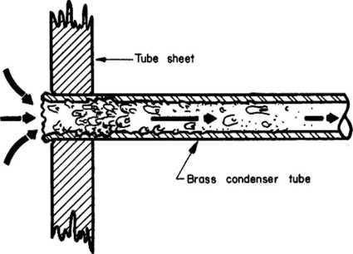

FIGURE ia INLET IMPINGEMENT ATTACK DUE TO EXCESSIVE TURBULENCE

When two metals of different potentials are galvanically coupled, the accieleration of the attack on the less noble metal of the two is observed frequently. It is well known that a small area of an anodic metal coupled to a large area of a second metal that is cathodic can be particularly dangerous. The reverse (namely, a small cathode coupled to an anode that is large in area), while not the most desirable situation, often proves satisfactory in service, A useful guide to help in predicting unfavorable combinations is the galvanic series of metals in sea water^c).

PROBLEMS ASSOCIATED WITH HEATING SEA WATER

As sea water is heated, a series of chemical changes take place which greatly alters its corrosivity to a metal such as steel. The discussion will first review briefly the scaling problem, then touch on other changes which affect corrosivity as sea water is heated.

V/hen a heated metal surface is brought into contact with brackish water or with sea water, the calcium and magnesium com­pounds will tend to precipitate• As the mineral scale grows in thickness, it tends to insulate the metal from the water, thereby impeding the flow of heat. This, in turn, is often accompanied by an increase in the temperature of the metal. The marine distilla­tion industry has been plagued for many years with the sea-water scaling problem, and many investigations have been conducted.

Research on the chemistry and the mechanism of scale for­mation has indicated that two conditions are important for the formation of sea-water scale:

1. The scale-forming constituents in the solution must be supersaturated. In the example just referred to, supersaturation tends to occur in the thin film of solution next to the surface of the hot metal. In laboratory demonstrations at Ann Arbor(8)， the W.

L. Badger staff have shown that there is an induc­tion period (sometimes of six or more hours) before the first scale nodule is precipitated from a supersaturated solution onto a cleaned copper sur­face .

2* Supersaturated constituents in solution need not have a metal surface for scale deposition* Suit­ably selected solids, suspended in solution, may also provide sites for nucleation of scale.

The formation and precipitation of the scaling deposits takea place primarily by the following simplified mechanism and ±e enhanced by the fact thfet the salts exhibit inverse solubility curves. First, it must be pointed out that the bicarbonate ion in the sea water is basically responsible for the low-temperature deposits (100 to 25〇 F)* This is true because as the sea water is heated and evaporated, the bicarbonate ions break up into carbonate iona, water, and gaseous carbon dioxide* A certain amount of the carbon dioxide is continuously lost• A condition is soon reached on the heated surface where the solubility product for calcium carbonate is exceeded and a layer of this compound is formed. Thia reaotion predominates in the temperature range of 1^0 to l8〇 F in an evaporator under dynamic conditions*

The second scaling constituent is formed because hydroly­sis of the sodium carbonate in the sea water is continuously taking place. Heating promotes this reaction and thus an accumulation of sodium hydroxide or hydroxyl ions tends to occur* Soon there are sufficient hydroxyl ions present to combine with the magnesium ions already in solution and magnesium hydroxide is precipitated* Ac­cordingly f heavy deposits of magnesium hydroxide are normally found at temperatures of l8〇 F and above. Figure 11 shows the relative amounts of magnesium hydroxide and calcium carbonate deposited at three temperatures(9)# It should be noted that a relatively con­stant amount of calcium sulfate was deposited at all temperatures.

When water temperatures (under pressure) of the order of 310 F to 325 F are reached, th^ scale becomes increasingly high in calcium sulfate because this material is less soluble at the ele­vated temperatures. Of the three types of depositt the sulfate is the most difficult to remove. Until an effective scale treatment is developed for calcium sulfate, a maximum of about 3〇〇 F is sug­gested for sea-water diatillation-plant designs.

Partridge and Whit10^studied calcium sulfate solubility in water* Apparently, hemihydrate is twice as soluble at about 29〇 F as anhydrite. As one Increases the temperature of seat 冒 the scale is mainly gypsiun at about 29〇 F, is hemlhjdrate at 315 F, and is anhydrite at about 330 F# Experience suggests that the gypsum is the least troublesome of the calcium sulfato scales to remove.

In a multi-effect evaporatort the sea water increases in aalini获 with each temperature increase* However, it has been foundin the lower temperature ranges that calcium sulfate does not reach saturation until sea water has been concentrated several­fold. Thus9 conditions can be found irhere distilled water can be produced and calcium sulfate depoaition be held to a minimum#

Sxperiment8 have shown that adding acid or certain acid salts to the incoming sea water greatly reduces the tendency to form calcium carbonate acale and magnesium hydroxide scale. From a corrosion standpoint9 it nornally is desirable to have a protective thin film of scale form on the metal, especially if the scaile ia bard «tnd impenetrable* Experienco has oho冒n that this raineral soal«

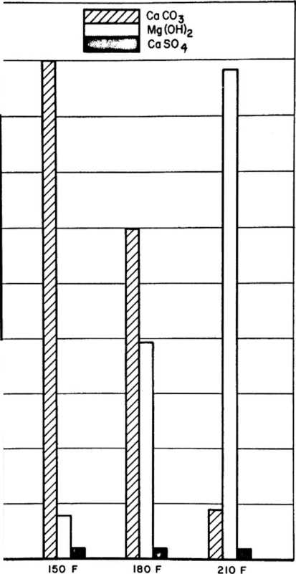

ALE COMPOSITION FROM BOILING SEA WA

affords considerable protection to metals, such as steel and cast iron, from the corrosive sea water.

The various methods for controlling scale formation from saline waters need to be examined from the corrosion viewpoint These include such chemical treatments aa (1) acid or acid salt additions to prevent calcium and magnesium compounds from forming, or (2) seeding to encourage the above compounds to form in solution away from the metal surfaces, or (3) the use of organic materials such as starch to cause a scale to form which is readily removed at scheduled intervals by mechanical means, such as thermal shook.

The addition of mineral acids (e.g., HC1) or of organic acids (evg., citric) would be expected to be accompanied by an increase in the corrosivity of the saline water• An acid salt addition, such as ferric chloride(D, or sodium bisulfate would also be expected to increase the corrosivity of sea water.

Seeding methods would not be expected to cause any marked increase in corrosion.

Since the early days of steam boilers, a variety of organic materials have been tried in boilers to prevent scale formation. In more recent y^ars, these compounds also have been tried in sea water. Some e?. imples include starches, tannins, sodium alginateThis type of addition probably has little influence on the corrosion attack of the metal by hot sea water.

Two proprietary treatments were mentioned in discussions of tMe scaling problem; one is called ^Hagevap1*). This treat­ment cosis about 2*7 cents per 1000 gallons of product when used at 3*8-ppm feed* The Hagevap treatment has been used on a land-based submerged-tube evaporator operating in the Persian Gulf; it has prevented scale formation during a year of operation* The boiling temperature of the sea water is limited to a maximum of about 200 F.

The feedwater treatment that has been adopted at Morro Bay, California, consists of various concentrations of Nalco Starch D-1557(巧）• For the past two years, the above starch treatment has been modified by adding Nalco 71NA antifoaming agent* These chemi­cals are mixed with fresh water and fed into the makeup line to the first-effect shell by means of a proportioning pump# The cost of this chemical treatment is 2*5 cents per 1000 gallons of distillate.

According to a short news release(I。， Dow Chemical Company (at Freeport) proposes to control calcium sulfate scale by partial ion-exchange softening.

PERFORMANCE OF M£TALS IN SALINE WATER

Steel

Compared to other metals, steel is one of the least expen­sive material of construction and is the basic material of construc­tion for many sea-water plants. Even though steel may be attacked in sea-water service as a distillation unit, its low initial cost may result in lower over-all costs if good design and good corrosion- control practices are followed.

The rate of attack for steel under immersed conditions in clean sea water at ambient temperatures is fairly uniform and aver­ages about 5 mils per year. General at tack, v/hen it occurs, con­tinues at a fairly uniform rate even with an accumulation of corro­sion products or marine growth.

Often, however, steel is subject to pitting attack by sea water. The pitting attack on bare steel is frequently reported to be about 10 to 15 mils per year. The presence of mill scale on the steel — especially when it covers a large portion of the exposed area 一 significantly increases the rate of pitting, and penetra­tions of about 20 mils per year, or more, can be expected* This is a result of the mill scale serving as large cathodes to the small, bare anodic areas. Pitting attack often tapers off with continued exposure.

A recent paper(工7)gives the results of an 8-year exposure of structural steels to tropical sea v/ater* It was found that small additions of copper to mild steel did not alter the corrosion rate. Steels containing 2 and 5 per cent nickel were definitely inferior to mild steel on the basis of both general and local attack. Steels containing 3 and 5 per cent chromium were more resistant than aild steel for the first three years, but then corroded significantly more than mild steel during the remaining five years. The amount of pitting also was greater for the chrome steels during the latter period* For complete immersion, mild steel is preferred. In other experimentsconducted in the polluted waters of San Diego Harbor, California, the rate of pitting for mild steel was found to be as high as 6〇 mils per year.

Welded copper-bearing oteol, 5/8 inch thick, is used for the shells of the evaporators in operation at the Morro Bay station of the Pacific Gas and Electric Company. These evaporators have a 228 F steam supply, and the brine temperature to the first stage is 190 F. In the vapor phase, the steel evaporator shells are showing corrosion where condensation occurs. The evaporator condenser shells show most corrosion where the third-effect vapor line enters. Con­densation with oxygen and carbon dioxide takes place at this point.

It is estimated that at the baffle the wastage was 10 to 15 per cent in about five years. Where the steel is brine covered, it is holding up well.

In connection with the pilot-plant operation of the Long-Tube Vertical Evaporator at Wrightsville Beach(19), tubes and test spools were exposed to temperatures up to 25〇 F and in sea­water brines up to four times normal salinity. Test-spool results of three selected runs are reported as follows:

Corrosion Rate, ipy

Firat Run Third Run Fourth Run

Test-Spool (30 Days) (♦ Days) (6k Days)

|  |  |  |  |  |  |  |
| --- | --- | --- | --- | --- | --- | --- |
| Metax | Vapor | Liquid | Vapor | Liquid | Vapor | Liquid |
| Steel | .027 | .oai | • 062 | .〇3〇 | • 〇57 | • OVf |
| Cast iron | .016 | .030 | .016 | .031 | .021 | .032 |

On third run, results were calculated for 1? days' evaporating time for the vapor samples, and on 28•缽 days for the liquid samples.

The exposed tube samples, for the most part, showed lower rates of attack than did the identical materials tested ae spools. This was explained by the fact that the test spools were exposed under rela­tively stagnant conditions. They conclude with the following：

•*The moderate amount of corrosion observed in the steel samples and steel tubes was encouraging to the point that steel cannot be discarded as a material of construction for heating surfaces in the LTV-type evaporator system. From the accumulated data and observation of the materials of con­struction used in the evaporator and tube equipment, it may be concluded that steel can be used as a material for the construction of the major portions of the evaporators, pumps， piping, and perhaps heating equipment* • •

•，As a broad, general conclusion, it ie highly probable that steel will turn out to be the best all-around material for economical operation. • •'*

The report also states: "Of the less-expensive non-

ferrous alloys, admiralty metal, copper, aluminum brass, and 90-10 cupro-nickel are entirely satisfactory on the basia of corrosion results

Protective Coatings* When heat transfer through the metal Is not involved, a protective coating often is the best method of preventing steel corrosion. The choice of a protective coating must be guided, among other factors, by the maximum intended water tem­perature. Steel has been protected by widely different protective coatings and linings, such as epoxy tar, vinyl, and rubber* Nor­mally, some temperatures between l6〇 and 25〇 F would be considered a good safe maximum for the best of the organic-type coatings* Metal linings, such as Monel, also are used to protect steel# Concrete has been used in sorae special cases,

A variety of protective coatings is available for steel in sea-water service. For such applications as hulls of shipst normal practice is to apply compatible antifouling paint over the corrosion- resistant primer-coating system. Figure 12-b shov/s panels which have resisted fouling for a year or more, compared with adjacent panels where the experimental coating does not prevent fouling*

Cathodic Protection, Steel can be protected by cathodic current, supplied either from sacrificial anodes or from an external direct-current source. The method is effective for completely im­mersed steel (that is, for surfaces on structures below the low-tide level)• Current consumption can be greatly reduced by applying a suitable paint system to the steel before it is immersed in sea water (see Figure 12-a). Such a paint system should be alkali resistant.

Current demands tend to increase with increasing sea-water velocity and temperature♦ Cathodic protection does not appear to be used in applications with hot sea water. Information is needed to establish the potential value of cathodic protection in sea-water installations at temperatures above, say, 100 F.

Scale Formation. One method of controlling the corrosion of steel is to allow scale to form from the water.

On the Gulf Coast, a steel heat exchanger in refinery serv­ice held up well under the following conditions* The process streams, to be cooled, varied from 3〇〇 to 600 F, The brackish-water tempera­ture was l8〇 F* The good results were attributed to a protective mineral scale. Another unit operating with 120 F water did not form scale, and the rate of corrosion was considerably higher.

For sea water or for brackish water, the thickness of the protective scale must be carefully controlled to prevent restrictions to water flow and to heat transfer. Normally, the water is treated to prevent scale formation and to increase the efficiency of heat transfer* One type of treatment is to lower the pH with acid or with an acid salt such as ferric chloride. This, in turn, will make the sea water more corrosive to the steel*

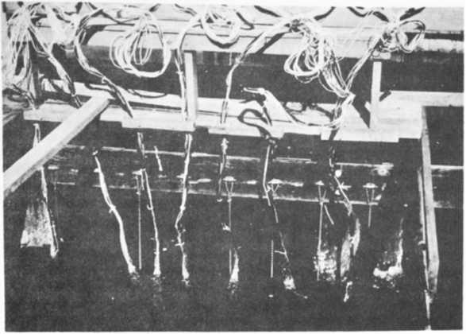

N-7〇l〇8

1. Effect of Cathodic Protection on Paint Systems

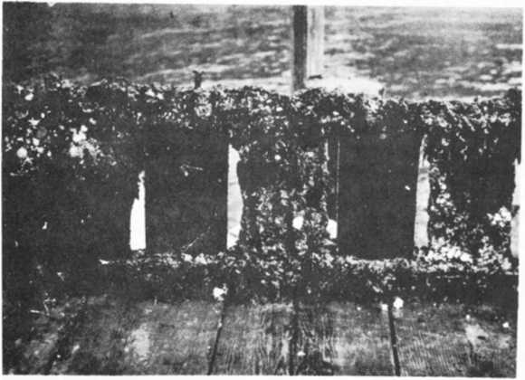

N-7〇l〇9

1. Antifouling Paint Studies

FIGURE 12. EXPERIMENTS AT BATTELLE»S DAYTONA BEACH MARINE STATION

Deaeration. F# C# Standiford has stated that by the use

of a deaerator to remove the oxygen in the sea water, it will be pos­sible to use eteel up to 25〇 F, Others believe that slightly lower temperatures (, 220 F) will be the maximum serviceable tempera­ture • This method is by far the most practical way of reducing sea­water attack. After treating the incoming sea water in a deaerator, oxygen scavengers such as sodiura sulfite or hydrazine(21)may be used. The maximum temperature at which this combined treatment will provide effective reduction in the rate of corrosion to steel is not yet known.

Other. Recent British experienced^^t using boiler water to which aea water"had been added, suggests that corrosion resistance can be improved by first chromizing the boiler tubes. No pitting was observed on these tubes* Unfortunately, some of the chromized tubes showed failures euch ae splits on being expanded into the tube sheets. The British also found some evidence that the degree of pitting is decreased by increasing the copper content of seamless tubes to about 0.2 per cent.

Another observation by the British authors is the danger of corrosion of otoel equipment used in saline waters during shut-down periods# During continuous operation, attended equipment can be better controlled than v/hen left unattended during idle periods. If chloride-containing water i6 allowed to remain in a boiler, there is a high risk of pitting attack. There are many methods already worked out for the preservation of steel equipment during idle periods.

Cast Iron

Many years of service have been obtained from heavy-walled cast iron pipe and oast iron equipment in eea-water service• Initi­ally, the iron phase in cast iron is readily attacked at rates simi­lar to mild steel. Normally, the layer of graphite left with the corrosion product is dense and compact, and the corrosion tends to be stifled* However, if this reoidual layer is porous, further corro­sion nay be accelerated by the galvanic action between the graphite layer and the iron beneath. The attack then approaches a rate simi­lar to that found for the pitting of mild steel*

Wrought Iron

Wrought iron has found considerable application in marine- based atruotures and in piping* While wrought iron, according to some sources, appears to be more resistant than mild steel to gen­eral and localized corrosion by sea water, there is no general ac­ceptance of this material by operators of marine plant6. Advantage is sometimes taken of its directional physical properties where cor­rosion roaietance also is needed. It sh-ould be mentioned that for the same initial cost a much thicker wall can be purchased in a cast iron or a steel pipe than for one of wrought iron. Until directly comparable engineering data are developed in the economic use of wrought iron versus steel or cast iron in sea-water plants, many experienced marine operators hesitate to specify wrought iron in place of other less-expensive ferrous materials*

It should be pointed out that an older form of wrought iron, as produced in England, contained slag layers• These layers, when suitably oriented, were found in some corrosion environments to prevent pitting attack from progressing deep into the metal*

While this behavior accounts for the longer lifetime of the ancient form of the material, it does not follow (according to marine spe­cialists) that the modern fibrous form of wrought iron will greatly outlast steel in identical sea-water service.

British wrought-iron boiler tubes^3)have given exception­ally long life in marine fire-tube boilers. These boilers use water to which sea water is intentionally added, A complex magnesium and calcium silicate scale is believed responsible for the long lifetime* The silicate is derived, in part, from the slag.

Aluminum and Its Alloys

In marine service, aluminum has already had considerable success in environments involving atmospheric exposure, such as the superstructure of ships of all sizes. It also is being used in structures and assemblies immersed in sea water.

For aluminum and its alloys, oxygen is found to be essen­tial in sea water for good corrosion behavior* Apparently, without oxygen to repair breaks in the protective oxide film， the metal is attacked rapidly. Other variables which affect the performance of aluminum must be considered also. For example, aluminum alloys are susceptible to pitting. Often the pits are very deep; however, the corrosion usually slows down with time. Pitting can be caused by deposits and by heavy metal ions such as copper plating out from solution and forming local cathodes.

Pitting and localized attack can be minimized by cladding the aluminum alloy with the proper grade of aluminum or aluminum- zinc alloy. The objective is to select a cladding that is slightly anodic to the base metal in sea water. Experience has shown that the attack will not penetrate into the base metal until most of the cladding has been consumed by corrosion. It is of interest to note that the aluainum usually chosen for cladding is both more corrosion resistant and slightly anodic to the base alloy* The fact that a metal is more anodic than an adjacent one in the galvanic aeries for sea water does not necessarily imply it will corrode at a higher rate when exposed uncoupled.

Alloys such as 3〇〇3 (1.2Hn), 5〇56 (5Mg)f or 6〇6l (l.OSi- 0.6si) are known to be more resistant to sea water than the copper- bearing alloys such as ZOZk (4*3Cu)-

Galvanic corrosion often is the cause of failure in aluminuni alloy designs# Aluminum, for sea-v/ater service, gives best results if it is not coupled to other metals*

Aluminum can be cathodically protected, but caution.must be employed. If there is too much alkali developed as a result of too high a cathodic current, the aluminum will be attacked.

Aluminum can be employed in hot sea wa七er as a resistant material of construction. Experiments by the U* S* Army, Engineering Research and Development Laboratories, and by investigators at other sites, indicate that, with proper corrosion-control practices, alumi­num can be used for the construction of an entire plant to process sea water* The sea water entering the plant should be free of all metallic ions, especially copper or nickel. It is essential, in such a plant， that no copper-base alloys be used at all, and that galvanic couples to most other metals be avoided.

In an aluminum-constructed distillation unit, local attack may occur at crevices such as those formed by a flange with a gasket. Recommended practice is to place such joints in the vapor phase, where differential aeration cells will not be operative•

As with aluminum in sea water at ambient temperatures, best results are obtained if aluminum-clad alloy construction is used.

There are reports of aluminum clad heat exchangers giving up to 10 years of service in sea water under favorable conditions.

Another example of the successful application of aluminum is in tankers. Steel-pipe heating coils, norcally used at the bottom of oil compartments in ship tankers, suffer corrosion resulting fron the alternating conveyance of sea water and crude oil of high sulfur content. In England, recent use has been made of aluminum-alloy heating coils. These are reported(2lf)to give equal or better results in all respects to a mild-steel steam system. Aluminum has higher rates of heat transfer and also there is a saving in weight and free­dom from corrosion. The cost of the aluminum-alloy installation is said to be only slightly more than that for mild steel. It should be pointed out that aluminum is resistant to sulfur-contaminated crude as v/ell as to sulfides and to sea water.

Copper

Experimentors studying distillation processes, in which a very low thermal gradient and good conductivity across the metal wall are required for success, would like to use copper(25,26,2?). Unfor­tunately, the corrosion resistance to sea water does not appear favor­able. In the rotor type of still, for example, the high velocity of sea water over the copper surfaces needed for efficient heat transfer also tends to promote rapid attack. Protective sea scale cannot be permitted because the reduced conductivity would adversely affect the design criteria.

Ordinary copper is not recommended for sea-water plants if the water velocities are much greater than, say, 2 ft/second. It remains to be demonstrated whether copper can be employed In contact with completely deaerated sea water at much higher velocities.

Experiments using a copper rotor with completely deaerated and heated sea water will soon be in progress at the Richmond Marine Laboratory of the University of California. Staff members at this site believe that copper may be a useful material of construction for hot sea water under these carefully controlled conditions.

Brasses and Bronzes

There is a wide range of copper-base alloys that have given good service in sea water. Admiralty brass (7〇Cu-29Zn-lSn) plus a small addition of arsenic, has found wide use as condenser tubes in marine-based plants using sea water for cooling purposes. While it is not so resistant as the cupro nickels, it often seems to be pre­ferred because of the lower initial cost.

Another alloy that is widely used in cooling-water service is aluminum brass (76Cu-22Zn-2Al). The aluminum content improves the resistance to velocity and impingement* This alloy, however, seems to be more susceptible to pitting than some of the other copper alloys in stagnant sea water.

Silicon bronze is suitable for shell material, but not suit­able for tube sheets subject to high velocity.

According to information received from the Tin Research Institute^S}^ tin-bronze condenser tubes (e.g., 9〇Cu-10Sn) are made to a limited extent in England. They are used only for special duty, namely< when the cooling water contains sufficient entrained sand and thus making erosion a serious cause of metal loss, or when the water is acid. Undoubtedly, their cost has restricted the wider use of these resistant alloys.

Research is in progress at the British Nonferrous Metals Research Association with brasses containing more than k per cent tin and with the zinc set at a maximum to provide for a single-phase alloy* in the laboratory test, these brasses have given good prom­ise in polluted waters and in resisting impingement attack— the corrosion being uniform. These alloys were first mentioned publicly in a discussion by H. S» Campbell

When either aluminum brass (76Cu-22Zn-2Al) or Admiralty brass (7〇Cu-29Zn-lSn) are used as condenser tube materials, an inhib­itor such &s arsenic should be added to the metal to prevent dezinc— ification. It is known that there is a greater tendency to dezinc- ification with increased temperature.

In the tabulation below(”，the inhibition of dezincifica- tion by arsenic in brasses is shown. These tests were conducted in corrosive well water at 176 F for 120 days. Although not given in

the reference, in all likelihood the water is contaminated with chlorides* It is predicted that tests in hot sea water would show a similar benefit for arsenic as an inhibitor*

|  |  |  |
| --- | --- | --- |
| Alloy | Weight  Loss,  ipy | Depth of Dezincificationf ipy |
| Aluminum brass | • 00A | 0.46(a) |
| Arsenical aluminum brass | • 002 斗 | Slight trace |
| Admiralty brass | ♦ 0030 | 0.15([1] |
| Arsenical Admiralty brass | .00^0 | Trace |

(a) Plug type.

The Standard Oil Company of New Jerseystudied the problem of the effect of metal temperature on the rate of attack in sea water. In one experiment, Admiralty brass single-tub© heat exchangers were made up and operated at metal temperatures up to 200R The incoming se.^ water was maintained at either 110 or 120 F* The experiment ran about 100 days. After the test, a comparison of the surface appearance of the Admiralty tubes v/as made by metallographic sectioning. Very little difference in the depth of attack was found with increase in temperature. There was a slight tendency for the surface roughness to increase with temperature.

Many refinery operators are of the opinion that corrosion failures of brass condenser tubes are more frequent during the hot season of the year. At some sites, warm-weather conditions coincide with longer production runs, higher plant through-put, higher salin­ity, higher cooling-water velocities, as well as warmer water supply for cooling purposes. In view of these variables, some corrosion specialists are not fully convinced that the greater frequency of failures in warm weather can be ascribed solely to temperature*

In condenser-tube service, if the water velocity is too low, air bubbles tend to form in the tubes as the water is being heated. These air (or gas) bubbles have been reported to initiate pitting. Once started, the pitting continues long after the bubbles disappear. This is just another example of the indirect effect of higher tem­peratures on corrosion.

Bruce(15)reports that aluminura^brass tubes (1-inch 0D, 16 BWG) are holding up well after five years in sea-water evaporator service in the Morro Bay, California, installation. These tubes are being used with rolled Naval brass tube sheets and with bronze float- ing-head covers.

Dual construction , using copper-base alloys in contact with staialess steel has been found unsatisfactory for sea-water serviceIn this use, the copper provides a large cathode, which

greatly increases the rate of attack of anodic sites on the stainless steel*

Cupro Nickels

At the present time, most marine operators agree that the cupro nickels are among the most useful materials of construction for sea-water plants. Since World War II, the use of a 9〇Cu-10Ni alloy modified with about has become well established* The lower

nickel content results in a cost advantage over the 7〇Cu-3〇Ni alloy. Alloys containing 7〇Cu-5〇Ni or 8〇Cu-20Nif each with added iron, are preferred by some designers to withstand more severe conditions* The cupro nickels are widely accepted as the best available alloys for condenser tubes.

For service in erosive conditions, a special copper-nickel alloy (3〇Ni-2Fe-2Mn) is useful and is normally preferred to bronze. In brackish waters, Admiralty brass is generally used if the total dissolved-solids content is below 2000 ppm. At higher dissolved- solids content, aluminum brass or the cupro nickels are favored. Cupro-nickel alloys are preferred to brasses in polluted waters. A useful survey of British practice is provided by P. T# Gilbert^^).

For service at higher temperatures,, the copper-nickel alloys are much preferred over other copper "base alloys.

Sea water, heated under pressure to 325 F, was allowed to contact three grades of cupro-nickel alloys for 5^ days at a velocity of 0*5 ft/second. The results(^), shown below, indicate that these materials are resistant to sea water at this temperature.

|  |  |  |  |  |  |  |
| --- | --- | --- | --- | --- | --- | --- |
| Cupro-Nickel Composition, per cent Alloy Cu Ni Fe Zn | | | | | (a)  Mn | Depth of Corrosion, ipy |
| 90-10 | 89.06 | 9.8^ | 0.71 | 0.20 | 0.19 | 0.0010(b ) |
| 90-10 | 87.85 | 10.07 | 1.7 | (c) | 0.24 | 0.0015((a) [2] [3] |
| 70-30 | 68.61 | 30.32 | 0.48 | 0 | 0.51 | o.ooo6(b) |

Tests were conducted^^ at the U» S* Naval Engineering Experiment Station, Annapolist Maryland, on the performance of ma­terials in high-temperature sea water, as follows:

Flat specimens, 2 to 2-l/^f inch long by 5/3 inch wide, were prepared from stock, 1/8 and l/l6 inch thick, and placed in electrically heated pressure vessels lined with 1^-8 stainless steel. The vessels were filled with l8〇0 ml sea water, and sealed after the air had been expelled.

The corrosion of eight specimens of 7〇-3〇 and 9〇-l〇 copper-nickel alloys v/as slight after days in natural sea water at 4^0 F under pressure; the surface etching was visible only with the aid of a binocular microscope* Corrosion rates, calculated from the weight losses, were only 0,14 to 0*2? rails penetration per year.

Four specimens of 7〇-3〇 alloy containing 0#^f6Fe and two samples of 9〇-l〇 alloy containing l*79Fe lost 0.27 to 0.29 mg/cm2.

For handling hot sea water, there has been some favorable experience with cupro-nickel pumps-

Cupro-nickel tubes of 7〇-3〇 and tube sheets of 9〇-l〇 are holding up well in evaporator service at the Morro Bay plant, Unit No. 2(工5). This service, however, is not considered severe enough to justify the expense of using cupro nickel*

From the viewpoint of corrosion in hot saline water, a helpful article was written by Turnbull(36)• Corrosion experiments were conducted in a four-effect evaporator. Experience has shown that 9〇-l〇 cupro-nickel heat exchanger tubes, at both high and low iron levels, and at velocities of to 5 ft/eecond, failed in less than two years by corrosion in hot, neutral, sodium chloride brines. These brines contained sodium, calcium, and magnesium chlorides and suspended crystals of calcium sulfate and sodium chloride*

A plot of the results of copper and copper-nickel alloys ia given in Figure 13* Between 100 and l8〇 F, there is a slight increase in the rate of attack. At the upper end of the temperature range, from l8〇 to 225 F, there is a tendency for the rates to increase more rapidly* Also of interest is the difference in rat© of attack between copper and Monel. With alloys of increasing nickel content, there is a very significant tendency for improved resistance to corrosion.

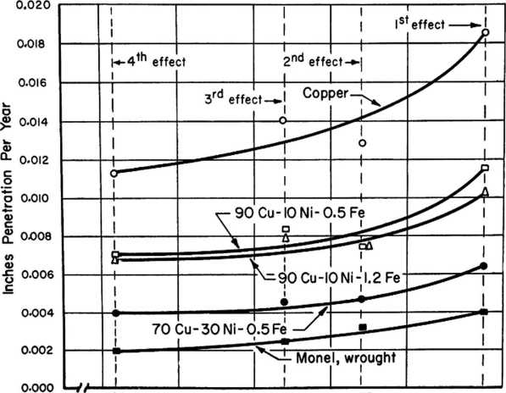

0 100 125 150 175 200 225

Temperature, F

FIGURE 13. CORROSION OF COPPER-NICKEL ALLOYS AFTER EXPOSURE TO NEUTRAL SALT BRINE FOR 185 DAYS IN A FOUR-EFFECT EVAPORATOR

Adapted from Reference 36

Monel

Extensive use has been found for Monel in handling sea water* It has given excellent service in heat exchangers, piping, sheathing to protect steel at the half-tide zone, valves, pump impellers, and fittings in general.

Monel shafts, such as the harder K Monel, are resistant to corrosion fatigue in sea-water service* Marine operators, in general, consider Monel to be one of the best all-around metals for handling sea water*

For distillation units and other hot sea-water applications, Monel can be expected to hav-e a higher order of resistance than cupro nickels* For example. Monel has been used in fabricating distillation units. In one type(9)， a Monel heat exchanger "basket" can be made to flex in order that the sea-water scale will drop off, thus restoring thermal efficiency* This service is considered much too severe for most metals*

Liiaited studies have been conducted on Monel in natural sea water at temperatures of and 69〇 37) # Although some of

those tetots were of short duration, Monel showed a rather heavy de­posit of corrosion products. In view of this, it would appear that temperatures of 35〇 F are beyond the useful range for Monel.

Stainless Steels

In special circumstances, under carefully controlled condi­tions, some grades of stainless steel have given good service in sea water. Most authorities, however, strongly recommend caution in the use of stainless steel for service in sea water.

In heat exchanger service, stainless steels can be used at much higher velocities than for most common metals. Nevertheless, there is the ever-present possibility that stress-corrosion cracking may take place. This becomes much more likely as the metal tempera­ture is raised. Any site at which both high stress and high chloride concentrations occur are particularly prone to this type of failure.

Stainless steel also is susceptible to crevice corrosion and deposit attack. Differential aeration cells, formed between stagnant and well-aerated areas on the metal surface, may promote rapid attack*

In general, Type 316， which contains molybdenum, is more resistant to the initiation of pits. However, once a pit is started, the rate of penetration may be of the same order as for molybdenum- free grades.

Since the process side in a heat exchanger may demand stainless steel, as in the case of a marine-based chemical plant that has been forced to use sea water for cooling purposes, it is neces­sary to consider measures for obtaining optimum service* First, the cooling v/ater should be free from solids which could deposit on the tubes. Next, the velocity should not be allowed to drop much below 5 ft/second. Crevice areas and stagnant areas should be minimized or eliminated by design. Finally, residual and service stresses should be held to the lowest possible levels* Under such carefully control­led conditions, stainless steel could give good service.

Stainless steel pump impellers are giving excellent serv­ice in sea water. The same may be said for stainless steel ship propellers now in use on some coastal vessels. In all cases, it is essential that the stainless steel items not be left in stagnant sea water for long periods between runs•

Stainless steel generally withstands polluted sea water and polluted brackish water better than do the copper-base alloys. At a West Coast power plant, substituting an austenitic stainless screen for silicon-bronze trash racks has resulted in at least four times the service life. Normally, stainless steel screens are not recom­mended for use in sea v/ater because of the crevices involved (where the wires cross each other). This alteration of the usual corrosion mechanism presumably is related to the hydrogen sulfide content of the polluted sea water and needs further study.

Titanium

Unlike other metals, titanium normally does not pit, is not susceptible to stress corrosion, is free from local corrosion under fouling organisms, is free from impingement and cavitation attack at velocities which attack copper-base alloys^ and is not susceptible to sulfide attack in contaminated sea water* Experiments with water velocities at 20 to 5〇 ft/second show no attack on titanium.

Titanium and its alloys are said to be less susceptible to mineral scaling in sea water than most other metals* (The corrosion products on a metal, such as steel, probably help to anchor sea-scale deposits.) Even though the thermal conductivity is low, the over-all efficiency, taking full advantage of the very hifjh velocities per­mitted, can be greater than presently used material in sea-water applications involving high rates of heat transfer*

Titanium cannot be coupled^^Ho most other metals in sea water, because of the greatly increased rate of attack on the other metal in the system (see Figure 1^). If the ratio of the "other metal" to titanium is 1:10, steel—instead of corroding at 5 mils per year—corrodes at the rate of 28*5 inches per year.

The effect is greatly reduced or eliminated if the :atio of the other metal to titanium is 10:1 (see right-hand side of Figure

At extremely high sea-water temperatures, titanium shows -little or no attack. A surface-protective film appears to be formed as indicated by discoloration^ There is no indication cf local attack

J09>-」0>0.co!loJI9ua)Q.</)a)Mocl

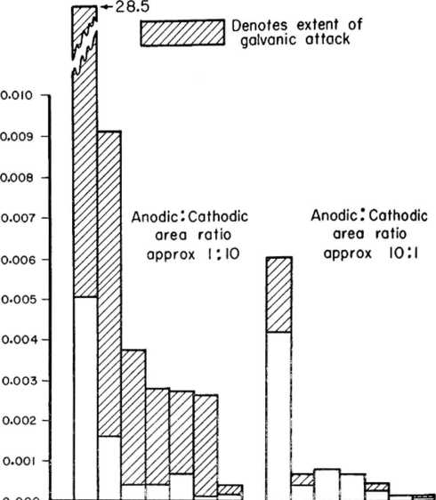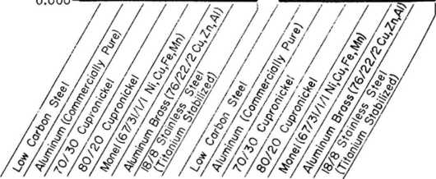

FIGURE 14. BEHAVIOR OF METAl-TO-TITANIUM GALVANIC COUPLES FOR 2500 HOURS IN AERATED SEA WATER

Adopted from Reference 38

such as pitting on titanium after exposure to sea water at tempera­tures of up to 69〇 F(57). 〇n the basis of these data， it was con­cluded that titanium is the preferred material of construction for such extreme service conditions.

Special Alloys

Hastelloy C compares favorably with titanium in its resist­ance to attack in sea water at both low and high temperatures* Little or no attack has been observed at temperatures up to 69〇 Fv37).

At the present time, Hastelloy C is being used by Freeport Sulfur at the hottest points in their system used to heat sea water to 32$ F under pressure for the Frasch process. It is understood that service performance has been very satisfactory.

Inconel is another nickel-base alloy which exhibits good resistance to sea water. Sea-water fog tests on stressed specimens exposed over the temperature range 125 to ^00 F have failed to indi­cate any susceptibility to stress cracking〇9). Under similar con­ditions, Type 3〇^+ stainless steel rapidly cracked.

In other tests(33)， inconel has shown promise of being re­sistant to sea water at F*

Tables 1 through 3 summarize the application and performance of metals in hot sea-water service.

|  |  |  |  |  |  |  |
| --- | --- | --- | --- | --- | --- | --- |
|  |  | Hot Salt Brine(a) |  | Hot Sea | Water |  |
|  |  | (e.fr* * Evaporators) | (Dynunic | Tests), Penetration Depth, ipy | | |
|  | Behavior^ 、 Remarks | | At 325 F(b) | At 35〇 F(c) | At 55〇 F(c) | At 69〇 F⑷ |
| Material | (5^ Davs) | (30 Davs) | (15 Days) | (145 Hr) |
| Copper(f) () Admiralty Brass' , | NF . | 1 Velocity and aera- |  |  |  |  |
| NF | > tion increases | 轉 | • | • | • |
| Aluminum Brass(f) | NF | J attack | - | • | - | • |
| 9〇Cu-10Ki-0.5Fe | 續 |  | 0.0010 |  | NF  NF |  |
| 9〇Cu-10Ni-1.5Fe(f> 7〇Cu-3〇Ni-0.5Fe(f) | E  E |  | 0.0015  0.0006 | 0.019(g) | - |
| Nickel | E | For neutral or alkaline brines | - | - | - | - |
| Monel⑴ | E | Most favored | - | 0.051⑷ | • | .015 |
| Inconel | G, P | NF in stagnant | - | 0.000l8(h) | - | • |
| AISI | G 1 | L NF in stagnant | • | 0.105(H) 0.0001 彳' 0,00005⑴ | NF |  |
| AISI 3^7 | G J | 1 conditions | - | NF |  |
| AISI 316 | G | Corrosion at welds | - | NF | - |
| Carpenter 20 | G | NF in stagnant |  | WG⑴ | NF | ■ |
| Hastelloy C | E | All temps, and pH 2.5 to 12.0 | - | WG, E | E | .0015 |
| Titanium | - | Should be excellent | - | WG, E | E | WG, E |
| Aluminum | P, NF | Some alloys may be good | - | - | 麵 | - |
| Cast Iron Ni-Resist | G  G | Brine should be kept deaerated | - | - | - | - |
| Steel | G.處 |  |  | r 了丨了 r |  |

1. Sodium chloride brine. See Reference 40; also some information taken froa

correspondence with specialists in leading salt companies.

1. See tabulation on page 31 of this report for details of the test.
2. See Reference 3^.
3. See Reference 37«
4. Nomenclature: B = excellent, G = good, P = pitting attack, NF = not favored,

-s no information, WG = weight gain.

1. Brines with hydrogen sulfide present will attack these materials.
2. Considerable corrosion products.
3. Slight contact corrosion*
4. Susceptible to stress-corrosion cracking if test period i5 extended.

TABLE 2. MATERIALS USED IN HOT SEA-WATER COMPONENTS

|  |  |  |  |  |
| --- | --- | --- | --- | --- |
| Item | |  | Material | Remarks |
| Centrifugal Pump Ditto  ii  ii  ii  " Type ’• Type | | | 7〇Cu-3〇Ki-〇.5Fe  9〇Cu-10Ki-1.5Fe  Monel  Carpenter 20 Bronze  316 Stainless 316 Stainless | Used for casing and impeller Ditto u  II  Used in hot brackish water  Excellent for impeller  Shaft failed by stress corrosion |
| Valve |  |  | M Bronze(a) | Valve body must be insulated from steel piping; good at 19〇 F |
|  | Evaporators, Heaters, and Other Heat Exchangers; Steel Shell; 19〇 F (Sea Water Plus Carbon Dioxide) | | | |
| Tubing  n  ii  n |  |  | ?6Cu-22Zn-2Al  9〇Cu-10Al  Admiralty + As 9〇Cu-10Ni-l，5Fe | Poor service  Poor service; cracks found in tubing  Failed in 3-1/2 years Very good performance |
| Tubing  Tubing | (b)  Sheet(b) | ?6Cu-22Zn-2Al + As Aluminum Bronze + Fe | | Brines up to 220 F and 57$〇〇〇 ppm chloride |
| Shell |  |  | Steel | Good performance reported in some cases; sea scale protec­tive |
| Shell |  |  | 9〇Cu-10Ni-0.5Fe | Considered excellent; largely eliminates galvanic couple, as with steel shell |

1. Porosity in casting successfully corrected by impregnating

with phenol-formaldehyde resin.

1. Proposed construetion.

TABLE 3. MATERIALS OF CONSTRUCTION, DISTILLATION UNITS AT MORRO BAY, CALIFORNIA

|  |  |  |
| --- | --- | --- |
|  | Material | Used |
| Item | Unit Number 1 | Unit Number 2 |
| Evaporators: | | |
| Shell  (a)  First-effect tubes | Cu-bearing steel | Cu-bearing steel |
| Al brass and As | 7〇Cu-3〇Ni-0.5Fe |
| Floating head | Cast bronze SB 61 | Cast bronze SB 6l |
| Tube sheets | Rolled liaval brass | 9〇Cu-10Ni-1.5Fe |
| Support plates | Rolled Kaval brass | tolled Naval brass |
| Vapor separator | Steel plate | Steel plate |
| Condensers: | | |
| Shell | Steel plate | Steel plate |
| V/ater box and cover | Cast iron | Oast iron |
| Baffles | Steel plate | Rolled Naval brass |
| Tube sheets | Soiled Naval brass | Rolled Naval brass |
| Tube supports | Steel plate | Rolled Naval brass |
| Tube，〉 | Al brass and As | 7〇Cu-3〇Ni |
| Hot well | Steel plate | Steel plate |
| Drain Coolers: | | |
| Shell | Seamless steel pipe | Seamless steel pipe |
| Shell cover, channel | Cast iron | Cast bronze SB 6l |
| Tube sheets | Rolled Naval braes | Rolled Naval brass |
| Baffles | Steel | Steel |
| Tubes | Al brass | Al brass |

1. 1-inch OD, 16 BWG.
2. 0.75-inch OD, l8 BWG.

DISCUSSION^ CONCLUSIONS« AND RECOMMENDATIONS

The selection of suitable metals to construct the plants is of prime importance to the success of the distillation programs of the Office of Saline Water.

For the corrosion of metals in 6ea water at elevated tem­peratures there is, unfortunatelyf a paucity of good experimental data. Even less information seems to be available on the actual performance of metals in hot sea-water service. Some of the same variables that affect corrosion at ordinary temperatures are believed to influence the corrosion behavior in heated saline waters.

Various examples have been given in natural and in salt water, indicating that the rate of attack is increased by raising the temperature.

The several types of attack associated with higher velocity (such as erosion-corrosion, impingement, and cavitation) probably also would operate in hot sea water, but not necessarily to the same degree. The chemical characteristics of the sea water or brackish water also must be studied in order to establish the effect of heating on the corrosion*

In general, higher teraperatures are associated • xth more local attack such as pitting. If scale or deposits interfere with hoat flow, local hot spots may develop. Bubbles of gas, forming at local sites, may promote corrosion pitting.

Slowly formed protective films on metal surfaces in contact with sea water at ambient temperatures may be quite different from those that occur in hot sea water.

In sea water, each metal and each type of environment must be considered individually. To isolate the effect of temperature, the sea water must be maintained in a state of equilibrium as it is heated. It will be necessary to treat it by chemical additions and to pres­surize the system. For example, if the presence of the dissolved oxygen and carbon dioxide is desired in hot sea water for an experi­ment, the pressure of the system will have to be increased and an oxygen/carbon dioxide atmosphere provided. Otherwise, these gases will leave the solution as it is heated， reducing the corrosivity of the water to metals such as steel. As already explained, if the carbon dioxide leaves the solution, scale will precipitate, which,if formed on the metal， prevents corrosive attack.

Information in the report suggests that steel can be used economically in plants employing completely deaerated sea water or brackish water up to 220 to 25〇 F. It is possible, by a suitable chemical treatment combined with deaeration, that steel could be used at a somewhat higher range of temperatures.

Aluminum-clad aluminum alloys also show promise for hot sea water where it is not convenient nor desirable to employ deaeration. The upper limits for aluminum appear to be lower than for steel. More precise information is needed to establish how much oxygen is neces­sary to promote the formation and repair of the protective oxide film in hot sea water.

Copper is not considered as being satisfactory for hot sea­water service. However, if it can be demonstrated that corrosion resistance to saline waters is improved by complete deaeration, this may revive interest in the use of copper in distillation units using a high velocity of flow, such as the several types of rotating stills.

For copper alloys, the order of merit in hot sea water is not clearly established. The upper temperature limit needs to be established, for each of the main copper-base alloys, below which the alloy can be expected to have useful service life.

Metals such as Monel, Inconel, Hastelloy CT and titanium may have application for special components in a hot sea-water system, in spite of their moderately high cost. A design study of a high- capacity plant using sea water should be mad© to establish the eco­nomics of using these materials if the initial investment is amor­tized over, say, 3〇 years.

This study of available information has emphasized the fact that (1) corrosion data for saline waters are very widely scattered»

1. much of the information on hot sea water concerns scale control with little attention given to the corrosion problem, (3) basic information for metals in hot brackish water and sea water needs to be developed, particularly for carbon ©teel, copper, copper alloys, and aluminum•

It is indicated that three types of corrosion programs should be inaugurated to develop the information needed for efficient design and use of metals in sea-water plants* namely:

1« A basic research program to investigate the mechanism of corrosion for carbon steel, copperT aluminum, and a few selected alloys in heated saline water. The hot water would be controlled so that the individual cor­rosion effects of temperature, salinity, oxygen, velocity, pH, etc•t could be established for each important metal• This research would have the objec­tive of indicating the range of usefulness for each variable* It would guide the planning of engineer­ing studies for a specific plant.

2. A coordinated program of corrosion testing in hot sea water. In this program steel, aluminum* copper alloys, etc.t would be evaluated in hot sea water under condi­tions in which factors such as heat transfer, scaling, and velocity were controlled to slightly more severe conditions than thos#» required in proposed service in new distillation plants. One objective of this pro­gram would be to obtain critically needed data to

assist designers in making (a) suitable corrosior： allowance and (b) provision for corrcsiori control. This program would help in planning and con­struction of distillation plants th&t are to last 20 years or longer.

3* The third corrosion program that v/ould be helpful is to collect information jiovy being developed at a. variety of brackish and sea-water plants in many parts of the world and correlate the aata-, Actual service information, where proper records of inspec­tions and evaluations are kept» is also cf great value in the planning of new construction- Trouble- s〇ne points, if recognized and understood from a study of present design failures, could be avoided or kept to a rainiicum*

ACKNOWLEDGMENTS

The author appeciates the assistance of his co-workers at Battelle in gathering raatorial for this report, in particular C* L. Peterson, V/, K. Boyd, and P. D. Miller for their contribution and J• C. Vargo for preparing the drawings.

Alex Allessandria

Messrs* J, Picarazzi, George Barnes. Herbert A. Robinson, and Richard 0, Norris Messrs. W. !>• Brooks, F* Mcllheimy, V. 3. Volkenins,

D* W. Pennington, E» Ludwig,

D. A* Ballard, C. M. Shigiey,

S. Stoval, "R, A* Freeiiian, and J. Hart

Mr. B* A. Axelrad

Person(s) Contacted

Mr. Ralph L. Eorst

Dr* W# S. Gillam, Messers* J* J. Strobel and E. A. Cadwallader

Freeport Sulfur New Orleans, Louisiana

Company or Agency

Aluminum Company of America New Kensington, Pennsylvania

American Chemical Society, Div. of Water and Waste Chemistry, Symposium on Saline Water Conversion

Arabian-American Oil Company- New York City

Cities Service Refining Corpn Lake Charles, Louisiana

Dow Company Freeport, Texas

Space and tirae, unfortunately, do not permit the author to mention all the numerous company representatives who kindly pro­vided helpful literature and information. The author wishes to thank, those personnally visited, in the following list, for their assistance in discussing the problem.

Humble Oil Research Laboratory Messrs. E. Q, Camp, R. V* Commeaux, Baytown, Texas Edward iVinegartner, and M* A.

Koseman

Maxim Marine Laboratory Kr. Bruce M. Watson

Lr. E. H. Phelps, Messrs. R. C. Bowden, Jr., R. L. Christian, R. J. Schmitt, C. K. Muller, and S. K« Coburn

Prof. Everett D. Kowe and Mr. John

T. Chambers

Mr« Richard J. Gainey

Kessrs. iV* Lee '.Villiams, Frank Clark, A. J. Ristaino, John L.

Basil t and Jack. Bauaan

Kr. Charles Tuley > Herrin S. Prdser an：! G»cr£：e Sj-rl-ir；

Dr* W* S. Gillara and Kr« £• A, Cadwallader

Messrs, V. F. Sstcourt and Elmer Johnson

Dr. T* P. May, Messrs. David Anderson, Victor Taylor, William Dawson, et al.

Dr. Aaron .Vachter

Messrs. H* E. Whistler and E. F* Bladholm (arranged by Tom Hotch­kiss)

Dr. H. P. Zell, Messrs. J. S* Cunningham, R. L. Piehl, and J. P. Arbizzani

Mr. V7illiam S. Quimby

Kessrs. William G, Ashbaugh and L. Miller Rogers

Messrs. Loren Neff and Max Ellis

University of California Sea Water Conversion Lab Richmond, California

Office of Saline Water Washington, D* C.

Pacific Gas & Electric Company San Francisco, California

Sea Horse Institute Wrightsville, Beach, N.C*

Shell Development Corporation Emeryville, California

Southern California Edison Co. Mandalay, California

Standard Oil Co. of California Richmond, California

The Texas Compare- Beacon. Nev； York

Union Carbide Chemicals Company Texas City, Texas

Union Research Center Union Cii 0〇• of California Brea, California

U. $• Army Engineers Fort Belvoir, Virginia

U. S. Naval Engineering Experi­ment Station Annapolis, Maryland

U. S. Navy Department Bureau of Ships V/ashington, D* C*

U. 〇• Steel Corporation Monroevillet Pennsylvania

Waterford, Connecticut

REFERENCES

A. Hache, "Contribution a l'Etude de la Corrosion de l'Acier en Solutions Saline'1 (in French), Institut de Recherches de la Siderugie, Series A, No. 138 (April, 1956); also, Revue de Metallurgie, No. 1, pp 76-80 (1956).

1. John Lyoand and Robert B. Abel, "Chemical Aspects of Physical

Oceanography", J* Chemical Education, Vol 35» PP 113-115 (March, 1958).

1. The Corrosion Handbook, edited by Herbert H. Uhlig, John Wiley

& Sons, Inc., New York City; Chapman & Hall, Limited, London (19W.

1. Ibid, p 111彡，Table 6.
2. Ibid, p 1116, Table 7.
3. Ibid, p 4l6.
4. Frank N. Speller, Corrosion - Causes and Prevention, McGraw-Hill

3ook Company, Inc., New York City (1951)，p 169.

1. E. Schaschl and G. A. Marsh, ’’Concentration Cells and Aqueous

Corrosion", presented at NACE 16th Annual Conference in Dallas, Texas, March 14-18, I960.

1. W* Palmaer， "Sur la variation de la vitesse de formation de la

rouille en fonction de la temperature", (in French), J. de la lutte contra la corrosion, pp 18-24 (November, 1938).

1. Bridgeport Brass Company, Condenser and Heat Exchanger Tube

Handbook (195^)» PP 76, 5〇，81 • 一

1. W. L. Badger and Associates, Inc” "Critical Review of Literature

on Formation and Prevention of Scale", U, S. Department of the Interiort Office of Saline Watert Research and Development Progress Report Ho. 25 (July, 1959).

1. W. R. Williamson and J. C. Stewart, "A New Look at Sea Water

Distillation", Society of Naval Architects and Marine Engineers (February, 1958).

1. E. P. Partridce and A. H. White, "Mechanism of Formation of

Calcium Sulfate Boiler Scale'*, Industrial and Engineering Chemistry, Vol 21, No, 9, pp 834-338 (1929). [4]

1. H« Hillier, uSea-Water Evaporation: Scale Prevention by Ferric

Chloride Addition", Chemical Trade Journal and Chemical Engineer, pp 306-311 (February 6, 1953).

1. H. Hillier, "Scale Formation in Sea-'.Vater Distilling Plants，，，

The Engineer, pp 208-209 (February 6, 1953)； also, pp 255-256 (February 13, 1953).

(1^) Hagan Chemicals and Controls, Inc., Pittsburgh^ Pennsylvania.

1. Albert W, Bruce, "Fiv$ Years Experience Making Fresh Water From

Sea Water at the Morro Bay Power Plant1% Colloquim on The Desalting of Water at the California Institute of Technology! Pa3adena, California (May 5-6, I960).

1. C&EN News, p 19 (July 20, 1959).
2. B* «V* Forgeson， C* R, Southwell, and A. L, Axlexander, MCorro-

sion of Metais in Tropical Environments: Part 5, Underwater

Corrosion of Ten Structural Steels", Corrocion, Vol 16, pp l〇5t-ll^t (March, I960).

1. M. H« Peterson and L* J* Waldron, "An Investigation of the

Corrosion Rate of Mild Steel in San Diego Harbor", NACS l6th Annual Conference in Dallas, Texas, March l^f-18, I960.

1. W, L. Badger and Associates, Inc*, ,f0peration of Pilot Plant LTV

Evaporator at Wrightsville Beach, North Carolina", Office of Saline Water, Research and Development Progress Report No- 26, p 92 (December, 1959)*

1. F, C« Standiford, Jr*fnBvaporation of Sea Water in Long-Tube-

Vertical Evaporators1*, ACS Symposium on Saline Water Conver­sion, presented at Cleveland, Ohio$ April i960； to be published by the American Chemical Society in Advances in Chemistry, in i960.

1. Axelrad and Brogdon, MHeating of Saline Water and Mining of Sul­

fur Therewith1', U. S, Patent 2,756,035, Column 6 (July 2k, 1956).

1. G. Butler and H, C. K. Ison, "The Corrosion of Welded or Coated

Mild Steel and of Wrought-Iron Boiler Tubes in Highly Saline Water", North East Coast Institution of Engineers and Ship­builders, Transactions, Vol 76, Part 3, Figure 3, p Ilk (January, I960).

1. Ibid, pp 95-130； Discussion, Part 5, pp 13-17 (March, i960).

(2k) T. J. Peake, "The Use of Aluminum in the Petroleum Industry11, Proceedings of the Fourth Y/orld Petroleum Congress, Section

Vii/B; Reprint No. 5, HIIeating Coils for Ship Tankersn (1955).

(25) R. L. Clark, K, J. Nabavian, L. A. Bronley, "Heat of Mixing and Boiling Point Elevation of Sea Water1’, Symposium on Saline

Water Conversion. Aaerican Chemical Society, 137th National Meeting, April I960.

(26)

K.

C* D. Hickman, Industrial and (1957).

♦♦Centrifugal Boiler-Compression Still^, Engineering Chemistry, Vol ^9» No* P ?36

1. J. A. Eibling, W. L. Buckel(Part I); K. C. D. Hickman, W. H.

Hogan(Part II), "Progress Report on Centrifugal Barrier Vapor_ Compression Distillationn, American Chemical Societyt Symposium on Saline Water Conversion, 137th National Meeting, April 5-1^, I960.

1. S, C, Britton, Tin Research Institute, England; private communi­

cation dated April l^t I960.

1. H. S, Campbell, "Some Factors Affecting the Performance of Con­

denser and *iv*at Exchanger Tubes,rt Chemistry & Industry, pp 142^-1425 (November 1, 1958).

(3〇) Private discussions at Engineering Research Laboratories in April of I960.

1. G. Newcombe, "The Effect of Composition and Structural Condition

on the Resistance of 18-2 Chrome-Nickel Steele to Electro­chemical AttackT,, Metallurgia, Vol 6lt pp 107-112 (March, i960).

1. P* T* Gilbert, "Some Factors Affecting the Performance of Con-

deneor and Heat Exchanger Tubes", Chemistry & Industryt Discussion, pp 888-895 (July 11, 1959)*

1. W* C. Stewart and F* L* LaQue, ^Corrosion Resisting Character­

istics of Iron Modified 9〇il〇 Cupro-Nickel Alloy"t Corrosion, Vol 8t No. S, pp 259-277 (1952).

(J^f) C, J. Lancaster, "Testing of Various Materials in High-Temperature Waters'*, E.E.S. Report 0^0028d, U# Sa Naval Engineering Station, Annapolis, Maryland (November 3〇, 1953).

1. C. J. Lancaster, ''Report on Performance of Materials Tested in

High-Temperature Sea WcXterM, E.S*S. Report ^A(13)96687〇, U. S. Naval Engineering Experiment Station, Annapolis, Maryland (September,

1. J* M. Turnbull, nSalt Refinery Corrosion Caused By Varying

Evaporator Conditions1', Corrosion, Vol l6t pp 11-16 (July,

I960). ^

1. G* L. Laserson, B. Minushkin, L, S. Goldring, and K, M. Held,

^Extraction of Fresh Water in the Supercritical State'1, Nuclear Development Associates, Inc., Report NDA 32-2 to the Office of Saline V/ater (July 31* 195^).

1. J. B. Cotton and B* P. Downing, '•Corrosion Resistance of Titanium

to Sea Water", Institute of Marine Engineers, Vol 69 No 8 pp 311-319 (1957). ’ • ’

BIBLIOGRAPHY

I960

1. Anon., "Results of Eight-Year Corrosion Tests Conducted by the U* S.

NavaJ. Hesearch Laboratory or. Ten Structural Steele and Wrought Iron8M, Engineering Service Department Report, A* K. Byers Company, Pittsburgh 22, Pennsylvania (i960)*

1. Frank G. Bennett, "Saline Water Conversion, X956〇$8Nt NAA-SR-5737 (Janu­

ary, i960); OTS, Department of Coairnerce, Washington 25♦ D»C*，price,

5〇 cents.

(?) Frederick W. Fink, '*Metal6 in Chemical and Marine Applications,'t Journal of Metals, pp 1^6-1^7 (February, I960).

1. J. H* Morgan, ^Cavitation Damage and Cathodic Protection,r, Letters to The Editor, Cheicistry and Industry, p 5&3 (May 21, i960).

($) T« Howard Rogers, Marine Corrosion Handbook, McGraw-Hill Company of Canada Limited, Nev; York, Toronto, London (i960).

1959

1. E* P. Anderson and T. ?. May, ''Hull Protection by Impressed Current",

Marine Sngineering/Log, Vol LXIV (January, 1959)-

1. Anon. f MAnti-Fouling and Corrosion Prevention Comliined in New System11,

Corrosion Technology, pp 364-365 (December, 1959).

C3) Anon.v "Preliminary Design Study of an Optimum Nuclear 3eactor-Saline Water Evaporator Process", Office of Saline Water, Research and Development Progress Report No. (1959)； 〇TS No. PB 161010.

(谷）A* Hache， L. Barriety, and J. Debyeer, uSffoct of Photosynthesis Upon the Corrosion of Steel in Sea V,,ater,t (in French), Corrosion et Anticorrosion, Vol 7, pp 56-61 (February, 1951); (in German), VJerkstoffe u. Korrosion, Vol 10, pp 1^5-148 (March, 1959).

1. Everett D. Eov/e, "The Costs of Demineralizing Water11, University of

California, Sea Water Conversion Prograa, paper presented at the UNESCO-IRAK Symposium on Salinity Problems in the Arid Zones, Teheran, Iran, on October 11-15* 1958; Series No, 75, W〇. 12 (February 25, 1959).

1. F. Hudson, Marine and Power Sngineers Meet in the United States, The

Mond Kicicel Company, Limited (I'haraes House, Milibank, London, S.W.l)i reprinted from Foundry Trade Journal (April 30, 1959).

1. John E* Morgan, "The Internal Cathodic Protection of Large Steel Pipes

Carrying Sea Water'S Corrosion, Vol 15f No. 8, pp kl?t-^22t (1959).

1. H. Peterson, "A Review - Principles and Criteria for Cathodic Protec­tion of Steel in Sea Water'*, Corrosion* Vol 15, Ho. 9， pp 483t-48?t (1959).
2. Howlands, "Stainless Steels and Related Alloys Versus M&rioo

Environmenta", Corrosion Technology, Vol 6, pp 359-363 (D«coob«r, 1959X

1. B. I. Smirnov, "Arc-Wtlding of Tube Conduit® in Copp*p-Nick»l Alloy*"

(in Ruaaian), Svarochnoe Proizvodetvo (Welding Production), Vol 32,

No. lt pp 35-37 (1959)； Engliah translation of journal available from British W«lding Research Association, 29 Park Crescent, London W. 1, England.

1. M« Thivin, "Sea Water Hesiatant Steels" (in French)t Corroaion et Anti-

corroaion, Vol 7, pp 195-202 (May, 1959),

1958

1. J* L* Basil and J* S* V/helen, "Sea 'Water Corrosion of Various Materials

Tested in Seven 20-Tube Model Condensers", Naval Research Laboratory,

U. S. Naval Engineering Experinent Station, £•£.£• Report No• 910027A (N3-6U3-078), 55 PP (March 21, 1958).

1. D. B* Brice» H* R* Dusbabek, and C* R. Townsend, "Study of the Applica­

bility of Combining Nuclear Reactors iVith Saline Water Distillation Proceeaea", Office of Saline Water, Research and Development Progroae Report No. 19 (1958); OTS PB Uo. 161391*.

1. B. F. Dodge and A* M« Cshaya, uEconomic Evaluation Study of Distillation

of Saline V/ater by Means of Forced-Circulation Vapor-Compreaaion Distillation Equipment", Office of Saline 'Water, Research and Develop­ment Progress Report No. 21 (1958)； 〇TS PB No. 161595*

1. S. Fukui and T. Hara, "Influence of Salt Concentration of Sea .Vater on

Polarization Curves of Various Metals" (in Japanese)， Corrosion Engineering, Vol 7» No. 5» PP 26-29 (September, 1958).

1. Griscom-Russell Company, ''Reaearch on and Analysis of Single-Effect Low-

Temperature Flash Evaporation Process"t Office of Saline Water, Re­search and Development Progress Report No* 18 (195^)? OTS PB No.

161393.

1. R, L. Horst, "Alunimio Pil« Casings", Aluminum Company of America, Sales

Development Division, Chemical Section (April 15* 1958)*

1. C. P. Larrabee, "Corrosion-Resistant Experimental Staela for Marine

Applications", Corrosion, Vol No. 11, pp (1958).

1. T. Minami and H. Takada, "Corrosion-Fatigue of Mild Steel in Sea Water:

Part I, The Influence of Cathodic Protection on the Corroaion-Fatigu#", Transactions, Shipbuilding Association of Japan, No* l〇3, PP 165-170 (May, 1958).

1. u, S. Navy, Bure攻u of Ships, Military Specifications, "Anodeo, Corroaion

Preventive, Zinc: Plate, Slab, Diec and Rod Shaped", MIL-A-18001E

(August 22, 1958)«

1. u. Navy, Bureau of Shipa* Military Specifications• "Pluga, * i.c Anode Retaining, Heat Exchanger, Cathodic Protection,,1 MIL-P-19^15n^HIPS)

1957

(1)

(2)

(3)

(6)

(7)

1. (9)

(10)



Abrancy, "The Effect of Different Factors on the Rate of Steel Corroaion by Periodic Wetting in S©a Water" (inf Russian)，Bulletin, Acad. Sci. of the Azerbaidzhan. SSSR (Invest. Amad. Naukmizerbaidzhan, 358)$ No. 8, pp 31-^0 (August, 1957)*

A. H. Byers Company, Pittsburgh 22, Pennsylvania, MA Structure Inspec­tion of the Marine Yacht Harbor Piers( San Francisco, California,

July 31 to August 2, 1957" (1957).

L. Barriety, J# Debyser, and A. Hache, "Changes in Sea-Water Charac- terietics in a Corrosion Testing Station" (in French), Corrosion «t Anticorrosion, Vol 5, pp 51-57 (February, 1957)-

V. H. Brogdon, ^Process and Heating System for Providing Hot V/ater and Power for Sulfur Mining", U.S.Patent No, 2,781,635 (February 19, 1957).

Louio Caruuo, "Selection of Tube Material Best Suited for Water Condi­tions" ,Phelps Dode« Copper Products Corporation, Elizabeth, New Jersey; paper, 18th Annual Wator Conference， Engineers' Society of Western Pennsylvania, Pittsburgh* Pennsylvania (October 22, 1957).

K.C.D. Hickman, "Reoearch Continuation of Badger-Hicknan Centrifugal Distillation Testing on Unit Number Office of Saline Water, Research and Development Progress Report No. 15 (March, 1957)•

F. L. LaQue, "Theoretical Studies and Laboratory Techniques in Sea '.Vater Corrosion Testing Evaluation1', Corrosion, Vol lj, pp 3〇3t-31^t (May, 1957).

John Starr, "Protective Coatings Made From Sea .Vater", Materials & Methods, Vol ^5, pp 188, 19〇, 192 (February, 1957).

O.S. Navy, Bureau of Ships, Military Specification, ''Anodes, Corrosion Preventive, Zinc; Design of and Installation in Shipboard Cond«nser0 and Heat Exchangers", KIL-A-19521(SHIPS) 25 Kay, 1956; Amendment 1 (April 1, 1957).

U.S. Navy, Bureau of Ships, Military Specification, MDistill*tion Unit, Water, Theriaoconpression,,f MIL-D-l6l96C(SKIPS) (December 3〇t 1957).

(1)

(2)

(3)

(^)

R. C. Adams, "Corrosion Problems of Naval Steam P〇7/©r Plants'*, Pro­ceedings, Aoericaa Power Conference, Vol 18, pp 583-590 (1956)•

B. A. Axelrad, "Sea Water Heating", U.S. Patent No. 2,756,207 (July 21*, 1956).

B. A. Axelrad, et al.t "Heating of Saline Water and Mining of Sulfur Therewith'*, U.S. Patent Ko, 2,756,035 (July 2k9 1956).

B. A. Axelrad.ct al., "Water Heating Proc«aaes for Sulfur Mining"

U.S.Patent Ko. 2,756,208 (July 24, 1956).

1. V* H* Brogdon, "Heating Systems for Water Containing Diaeolved Scal«-

Forming SolidB*', U.S. Patent No, 2,756,029 (July 2kt 1956).

1. C« H. Cockrell, •'Pressurized Beater for Producing Hot Proceaa Water ia

Large Quantities from Scale-Forming Water'1, U.S. Patent No. 2,759,328 (August 21, 1956),

1. W. W. Cranmer, uRec«nt Navy Experience vath Saran and Vinyl Co&tinga",

Corrosion, Vol 12, pp 2^5t-2^6t (May, 1956).

1251

1. Aluminum Company of America, ,fProceas Industries Applications of ALCOA

Aluminum", p 75 (1955).

1. W. L* Badger and F. C« Standiford, "Engineering in Salt Manufacture1',

Chemical Engineering, Vol 62, Nos. 3 & pp 173-177 and l8〇-l83 (1955)*

1. H* Barnee, "The Analysis of Sea Water; A Review", Analyst, Vol 8〇, No. 953.

pp 573-592 (Auguot, 1955)•

(^) Charles J. Fritts, "Corrosion Control on Offshore Drilling and Producing Equipment", Corrosion, Vol 11， pp 471t-476t (November, 1955).

1. J. LeicesterT ••Developments in Feed Water Treatments’1, CorrosionPr«ven-

tion & Control, Vol 2, No. 5» PP 33-37 (1955).

1. T. J, Peake, MThe Uae of Aluminum in the Petroleum Industry’’， Proceedings

of the Fourth V/orld Petroieua Congress, Section VIl/B, p 137 (1955)• *

1. A. D. Rust, nThe U«e of Sea Water in Industry11, Southern Power 8c Industry,

PP 50-52 (Deceraber, 1955)*

1. A. N. Voripaieff, ’’VJrou尽nt Iron Beate Salt-Water Corrosion on Offshore

Platform1', Oil Gas Journal, Vol 5^» No. 28, p 197 (1955)； also Marine Engineer, Vol 6〇, No. 11, p 6l (1955)*

Iga

1. Anon.t "Cast Monel Impeller", Materials 8t Methods, Vol 39. No, 3, p ll^f

(195“）•

1. W, B. Brooks, ''Sea Water as an Industrial Coolant: Part 1, Operating

Condition6u, Petroleum Refiner, Vol No. l〇» PP 127-130 (19$^).

(5) w. B. Brooks, "Seawater as an Industrial Coolant: Part 2, Equipment

Experience*', Petroleum Refiner* Vol 35, K〇. 11. PP 179-1S2 (195^+).

1. p. t, Gilbert, "The Resistance to Failure of Condenser and Heat Exchanger

Tubes in Marine Service'*, Transactions, Institute of Marine Engineers, Voi 66， pp 1-6; Discussion， pp 6-20 (January, 195^).

1. p. t. Gilbert and F. L. LaQue, "Jet Impingement Tests'*, Journal of the

Electrochemical Society, Vol 101, pp ^8-^55 (September, 195^).

1. A. Hache and P. Deachampe, HStudy of Sea Water C〇rr〇eivityu (in French),

Corrosion et Anti-Corrosion, Vol 2, No* pp 13^-1^0 (July-August, 195^); also Publications, Institut de Recherches de la Siderurgie, Series A, No. 9〇* 7 PP (November, 195^)•

1. J. W. Jenkins and J. B. Guerry, "Testing of Materials for Naval Ship-

board Sea Water Carrying Systems - A Review'1, Journal of the American Society of Naval Engineers, Inc” Vol 66, No. 5 (August, 1954); pub­lished by The Internationai Nickel Company， Inc” 67 Wall Street， New York 7, New york (195^).

1933

1. Anon., "Behavior of Light Metal Alloys Towards Sea Water" (in German),

Aluminium, Vol 29» No. PP 205-206 (1953).

1. Anon. "The Marine Corrosion Station of the I«S.M.L*" (in Italian),

Alluminio, Vol 22% No# pp k2k-kZ6 (July, 1953).

1. British Cast Iron Research Association, "Behavior of Cast Iron in Sea

Water: An Annotated Bibliography11, Bulletin, Vol 12, No. lt pp 8-1 乜

(July, 1955).

1. V. J• Chir, F. H* Colonutt» and K* Turner. ^Sotne Corrosion Problems

Encountered in Hina-Al-Ah-Madi Refineryr,$ Institute of Petroleua Review, Vol 7* PP 159-16^ (May, 1953).

1. W* J• Danziger and 0« A* Sundhoim, ^Protection of Heat Exchanger Channels

and Covers irom Corrosion by Salt Water' American Society of Mechanical Engineers, Pi^pi'int 52-A-1^5 (ASMS Annual Meeting, November 30-Decenber 5, 1952, New York Cxty), 22 pp (1953).

1. F. L. LaQue, ^Results of Exposure of Steel, Ductile Iron, and Ductile

Nickel Resist Bolts in Contact V/ith Cast Iron to Flowing Sea Water at Harbor Is]and， North Carolina, for 9〇7 Days (April 1951 to October 1953)", Harbor Island Project Report 3〇〇9.3» The International Nickel Company, Inc. (Decambsr 18. 1953).

1. C. P. Larrabee, ''Corrosion peeiatance of High-Strength Low-Alloy Steele

aa Influenced by Composition and Environnent", Corrosion, Vol 9, No. 8, pp 259-271 (1953).

1. A, J, Maurin, "Rational Anti-Corrosion Measures - Corrosion of CondenBer

Tubes" (in French), Techniques et Applications Petrole, Vol 8, pp 2593- 2596 (April, 1953).

1952

1. Anon.| "Corrosion Resistance of Titanium", Wastinghouse Engineer,

Vol 12, pp 114-11? (July, 1952).

1. Anon., MReport on V/rought Iron for Salt Water Piping*', U.S« Naval

Engineering Experiment Station (Annapolis, Maryland)• Report No« ^A(9) DT169 (April, 1952).

1. R. L* Davis and R. F. Heinzerling,'How Bahrein Petroleum Combats Sea-

Water Corrosion at Persian Gulf Installations"t Oil Gas Journal, Vol $1, No. 3?, PP 264, 266, 268 (December 22, 1952),

W K* M« Huston and R. B. Teel, ♦'Some Observations of th« Potentiale of Stainless Steele in Flowing Sea Water", Corrosion, Vol 8, pp 251-256 (July, 1952).

1. C* J* Lancaster, "Performance of Materials Tested in High Temperature

S«a V-fatert *K' Monel Metal Chromium Plated'*, U.S. Naval Engineering Experiment Station (Annapolis, Maryland), Report No* 4a(15) 966870 (January, 1952).

1. National Association of Corrosion Engineers, "Corrosion- A Short Coureof,,

Symposium held at University of California* in cooperation with the National Association of Corrosion Engineers, February 舁着8， 1952.

1. W. S, Patterson and A. Vf. Jones, *'A Contribution to the Study of the

Action of Certain Inhibitors Upon Corrosion in Chloride-Polluted V^ater11* Journal of Applied Chemistry (London), VoX 2, No. 5» PP 273- 28〇 (1952).

1. I. G* Slater, L. Kenworth, and R* May, "Corrosion and Related Problems

in S©攻-Water Cooling and Pipe Systems in E.M* Ships"t Journal of the Institute of Metals, Vol 77, Part pp 3〇9-33〇 (195〇)； Corrosion,

Vol 8t No, 12, pp 417-429 (December, 1952).

1. w. C. Stewart and L. LaQue, ♦'Corrosion-Resisting Characteristics of

Iron Modified 9〇:10 Cupro Nickel Alloy'S Corrosion, Vol 8, No. 8, pp 259-277 (1952).

1. D. p. Thornton, Jr., MDow Conquers Sea V/ater Corrosion,,l Petroleum Processing, Vol 7, No* 11, pp 16^0-16^3 (1952)*

1951

1. 0. L* Bailey, ,,Copper-Niclcel-Iron Alloya Resistant to Sea-??at©r

Corroaion1', The Institute of Metals Grosvenor Gardena, London SW 1); reprinted from Jourzial of the Institut© of Metals* VoX 79i Part pp 2U3-292 (1951).

1. G, Heinemann, '*ProblemB of Industries Using Sea Water (as Cooling

Medium)", Texas Journal Science, Vol 3» PP 311-3^1 (195D*

1. L. W. Johnson and E. J* Bradbury, MCorr〇6i〇n-Resistant Materials in Marine Sagineering*'t The Chartered Marine Engineer, Vol 2, No. 1, p 1 (1951)； reprinted by The Mond Nickel Company, Limited,

(^) C. M. Shigleyf ,rEngineering Problems of Coastal V/atcrs,T, The Texas Journal of Science, Vol 3, No# 1, pp 21-29 (March 3〇t 1951).

(5) E. T. Wandered, "Aluminum Marine Pip© Line**, Oil Gas Journal, Vol 5〇t No. 9, pp 58-76 (July 5, 1951).

1212

1. Anon.T ,f0n the Corrosion Resistant Properties of Ferritic and Pearlitic

Ductile Iron:\ Nickel Topics, Vol 3, No. 9, P 8 (195〇).

1. F* L. LaQue and J« F. Mason, Jr., "The Behavior of Iron Modified 70-30

Cupro-Nickel Alloy in Sea Water and in Some Petroleum Industry Environments", Proceedings 15th Mid-Year Meeting, American Petroleum Institute, Refining Division, Cleveland, Ohio (195〇).

1. V. P* Volkening, "Corrosion of Steel Pipe by Chlorinated Sea Water at

Various Velocitiest,t Corrosion, Vol 6, p 125 (195〇)«

19^9

1. H* S. Bethon, "Fouling of Marine-Type Heat Exciiangers"t Transactions,

American Society of Mechanical Engineers, Vol 71, p 855 (19^9)•

1. W, Z. Friend, f,Sea Water for Cooling"t paper, AXChS Symposium on Water

Problems of the Process Industries, New York City, 55 pp, November 17,

W9.

1. A* J. Gould, MCorrosion-Fatigue of Steel Under Asymmetric Stress in

Sea Water", Journal Iron Sc ?；teel Institute, Vol l6l, pp 1X-16 (19^9).

(^) H. A. Humble, "Thtj C?>bo<ii〇 Pl^tection of Steel Piling in Sea Water", Corrosion, Vol 5» P 292 (19^9)*

(5) I• G. Slater an$ N. L* Parr, "Marine Boiler DeteriorationT,« Proceedings, Institute of Mechanical Engineers, Vol 160, No. 3, pp 3^fl-358 (lW)； Engineer, Vol 18?, pp 158-161, 199-201 (February XI, l8t 19^9); Corrosion, Vol 5, No. 12， pp hl7~K3b (19^9).

(6) D. Wyllie and G. C. N. Cheesman, "Sodium Nitrate as an Inhibitor

Against the Attack of Sea Water on Steel: Part II, The Addition of

Other Inhibitors to Nitrite", Journal, Society of Chemical Industry, Vol 68, pp 209-212 (July, 19^9).

19^8

1. W. F• Clappt nMaoro~organism8 in Sea V/ater and Their Effect on

Corrosion", Corrosion Handbook. Edited by H, E. Uhlig, John Wiley 8t Sons, Inc., New York City (19^8), pp

1. H, A, Humble, MCathodic Protection of Steel in S«a Water With Magnesium AnodesM, Corrosion, Vol p 358 (1948).
2. F. L. LaQue, ^Behavior of Metals and Alloys in Sea V/ater,f, Corroaion Handbook, Sdited by H« H. Uhlig, John Wiley & Sons, Inc.» New York City (19沾），pp 385-429•
3. A* C. Rodfield, "Characteristics of Sea Water"t Corrosion Handbook,

Edited by H* H. Uhlig, Joim liViley & SonsT Inc*, New York City (19^8),

pp 1111-1122.

1. G. W. Seagren， uPainte and Organic Coatings for Sea-Water Exposure", Corroaion Handbook, Edited by H. H. Uhlig, John Wiley & Sons, Inc,, New York City (19W)» pp “31一55.
2. Q. H. Young, 11 Anti-fouling Measures'*, Corroaion Handbook, Edited by H， H. Uhlig, John Wiley & Son3， Inc,7 New York City (19^8), pp ¥*6.

19“6

(1) J. ?；• Cuthbertson, "The Resistance to Corrosion by Sea Water of Some

a-Tin and a-Tin-Aluminura Bronzes"t Journal of the Institute of Metala, Vol 72, pp 317-3^2 (19^*6).

(2) F. Wormwell, "The Influence of Movement on the Corrosion of Metale in Salt Solutions and Natural Waters: Part I, Low-Speed Rotation of

Mild Steel - Peripheral Velocities Below 100 ft/nin", Journal of the Tron and Steel Institute, No. II* pp 219p-228p (19^6).

1. E. H. Wych«t L. R. Voigt, and F. L. LaQue, '*Corrosion in Cr®vices'»f Tranaactionst Zlectrocheioical Societyi Vol 89t PP (19^6)#

1. Method of determination not reported by supplier,
2. No pitting.
3. Not reported.

   Dynamic corrosion tests at 55〇 F have been conducted by Lancasterin natural sea water. Specimens were rotated at a peripheral velocity of 10 ft/second while under a bending stress of one-third the tensile strength of the material. In these studies, it was found that the copper-nickel alloys were unsatisfactory because of excessive weight losses from erosion.
4. Ulick R. Evans, The Corrosion and Oxidation of Metals: Scienti­

   fic Principles and Practical Applications, Martins PressT

   Inc., l‘c..v York City (I960), pp