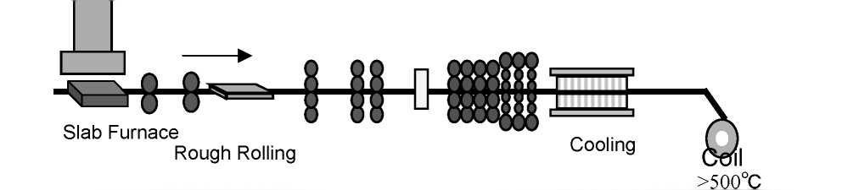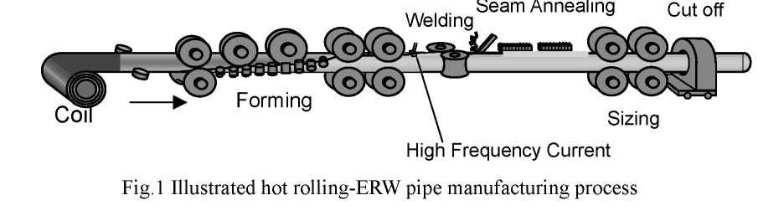
Development of API X-80 grade electric resistance welding line pipe
with excellent low temperature toughness

[Introduction]
Thick-walled high strength line pipes are increasingly used for high-pressure pipeline operation to improve the transportation efficiency for natural gas and oil. It is needed that the line pipes have higher yield strength and larger thickness. However, the higher strength such as API X-80 grade, the lower the fracture toughness. Moreover, natural gas and oil mining have been performed and pipelines were constructed severe environment, like the arctic region, low temperature toughness of the line pipe is necessary.
Until now, to satisfy both requirements of the high tensile properties and the low temperature toughness, thick-walled X-80 and greater grade line pipes was developed by plate-UOE pipe manufacturing process¹⁾²⁾³⁾. These were introduced bainite single phase transformed at very low temperature with ultra low carbon steels to keep coarse hard secondary phase away to improve the toughness. On the other hand, by hot rolled sheet to ERW (electric resistance welding) pipe manufacturing process, X-80 line pipe steel with bainitic microstructure made by low stop-cooling temperature was also studied⁴⁾. The ERW process can gain higher production rates, however, it was difficult to obtain bainite microstructure with good toughness because coiling process is indispensable. Fig.1 shows the ERW production process. In hot rolling, stop-cooling is necessary before coiling at 500 to 700 degrees C generally. The stop-cooling temperature of hot rolled sheet is very higher than that of plate, which is less than 350 degrees C. So it was difficult to obtain good toughness by the lower bainite microstructure as same as the plate-UOE processed pipes by the ERW process.
In this paper, solution of above issue was studied and a new microstructure for X-80 ERW line pipes, which has precipitation hardened bainitic ferrite microstructure, with low Pcm value for good weldability was developed.

Hot Rolling
Finish
Rolling

Pipe Forming and Welding
1
HOME
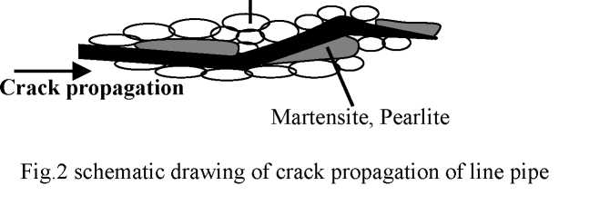

2.Design Concept
To improve the low temperature toughness of the pipe, the performance of steel sheet, mother material of the pipe should be improved. As for ERW pipes, toughness of two parts has to be ensured simultaneously. One part is base material and the other is weld. However, weld has the same chemical composition as base material. First of this study, the effect of chemical composition and microstructure of the steel sheet on the toughness was investigated. The increase of alloying elements degrades the toughness. It was found that higher carbon equivalent of the base material made toughness of weld worse due to the hardenability. These are in good correspondence. Also, higher absolute carbon content degrades the toughness of the base material respectively because coarse carbides precipitate. The performance of the base material also depends on the microstructure. Fig.2 is a schematic drawing of crack propagation of line pipe steel. It’s thought that grain refinement and deduction of coarse polygonal ferrite and carbide are efficient to avoid crack propagation.
As described in the fist paragraph, the ERW pipe material has to be coiled to produce. So we studied the way to utilize the heat cycle to optimize chemical composition and sheet manufacturing condition., The features of the heat cycle are that stop-cooling temperature is nearly the same range of precipitation hardening, and sheet coil is cooled very slowly after coiling. It is suitable for using precipitation hardening by addition of microalloyed element like Nb, V to gain the strength, but, hard secondary phase is tends to be precipitated and ferrite grain growth would occur. So we investigated the countermeasures as follows:
1)Reduction of carbon to extremely low level to reduce hard secondary phase like pearlite and
martensite
2)To avoid the precipitation of coarse ferrite and pearlite on cooling
Thus, it was achieved that extra-low carbon steel with single phase of bainitic ferrite microstructure that is fine and has few coarse types of carbide is suitable for this subject. Then, how to obtain the bainitic ferrite microstructure by extra low carbon steel during hot rolling was investigated. It was found that the addition of the elements for hardenability like Mn,Cu,Mo, is effective to make ferrite transformation temperature low, and pearlite transformation slow. Thermomechanical controlled process (TMCP), which comprises controlled rolling and accelerated cooling during hot rolling is also in use by minimized carbon equivalent of chemical composition for good weldability and toughness of weld.
Ferrite
2
HOME
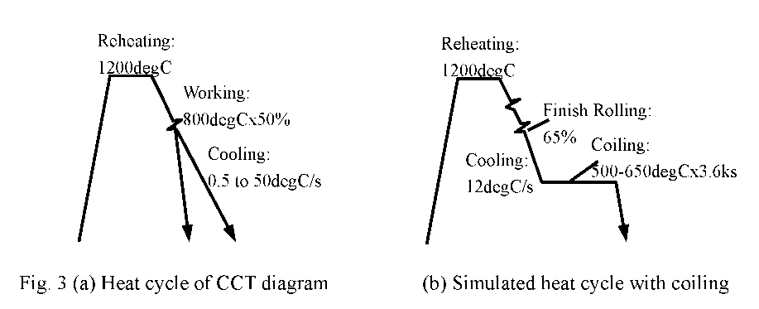
- EfTect of carbon content on microstructure of material
  - Experimental procedure
The chemical compositions of steels used are shown in Table 1. The steel A was a conventional low carbon X-80 grade steel for warm environment. Steel B is the extra-low carbon steel designed as X-80 for low temperature use as mentioned above. steel B was examined to draw the continuous cooling transformation (CCT) diagram to find the cooling condition to obtain bainitic ferrite microstructure. Fig. 3a illustrates the heat cycle of the CCT test. Samples were strained at 800 degrees C before cooling to substitute the effect of finish rolling. Laboratory hot rolling with coiling cycle were carried out to test the effect of reduction of carbon content on the microstructure. Steel A,B were hot rolled, holding in the furnace at coiling temperature, 600 degrees C and microstructures were examined. The heat cycle of laboratory rolling is shown in Fig. 3b. For Steel B, the effect of coiling temperature on tensile properties was also examined.
Table 1 Chemical Composition of the steel used (mass%)
Steel | C | Si | Mn | P | S | Nb | Others | Pcm
A | 0.06 | 0.25 | 1.62 | 0.01 | 0.003 | 0.05 | V,T!,Mo | 0.16
B | 0.03 | 0.23 | 1.62 | 0.014 | 0.002 | 0.05 | V，T!,Cu,Ni,Mo | 0.15
Pcm=C+Si/30+(Mn+Cu+Cr)/20+Ni/60+Mo/15+V/10+5B
  - Results
The transformation behavior is shown in Fig. 4. Bainitic ferrite transformation start temperature was near 600 degrees C and critical cooling rate was 10 degC/s which is ordinary cooling rate on hot run out cooling table for line pipe steel. Polygonal ferrite which transformed at higher temperature than the bainitic ferrite, and pearlite transformation temperature was above 600 degrees C in case of the cooling rate was less than the critical cooling rate. These polygonal ferrite and pearlite are relatively coarse because its transformation temperature is higher than the bainitic ferrite. This results indicates that bainitic ferrite microstructure in use of extra-low carbon steel can be obtained during hot rolling process when stop-cooling was carried out under 600 degrees C.
3
HOME
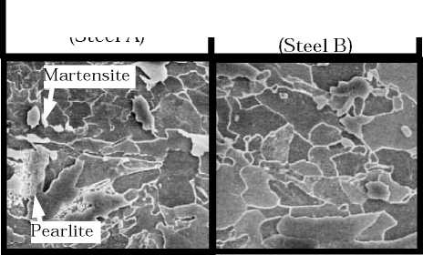
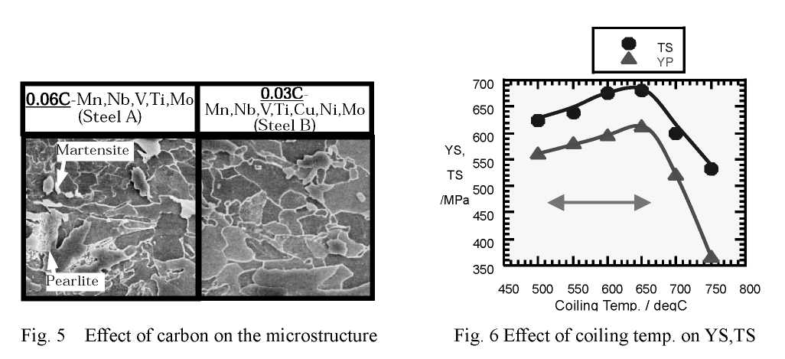
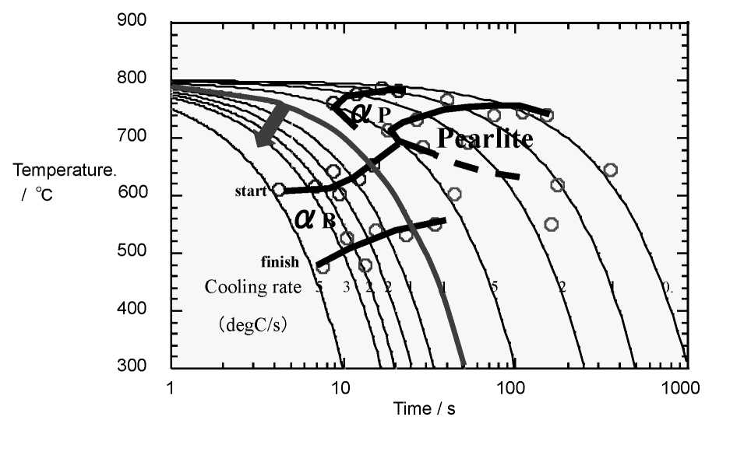
Fig. 4 CCT diagram of steel B
Fig.5 shows the microstructure hot rolled sheet of steel A and B after coiling cycle. The microstructure of Steel A, 0.06%C steel, contained pearlite and martensite. The microstructure of Steel B, 0.03%C steel, was bainitic ferrite with no pearlite and martensite. This result showed that bainitic ferrite single phase could be obtained as hot rolled.
The effect of coiling temperature on strength of steel B showed in Fig. 6. Bainitic ferrite microstructure was obtained in the range of 500 to 650 degrees C of coiling temperature and these had enough X-80 yield and tensile strength (YS, TS).

4
HOME
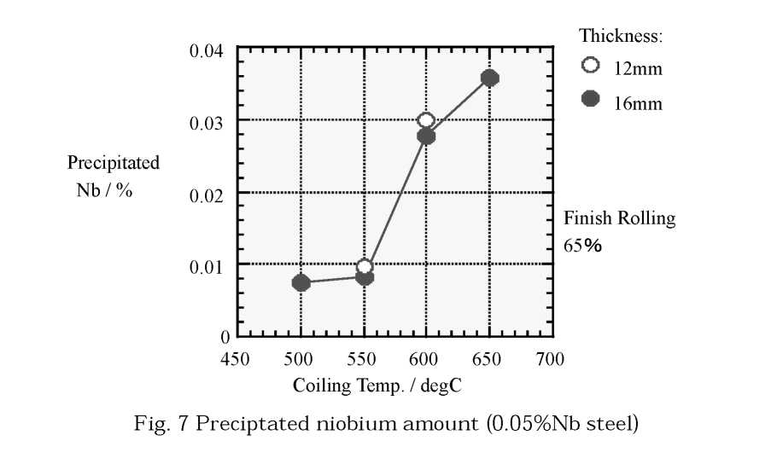
  - Discussion
To estimate the amount of precipitation, Fig. 7 shows the amount of precipitated Nb which was measured by dissolution extraction method. At 600 and 650 degrees C of coiling temperature, strength and precipitated Nb raised up. It is thought that large amount of fine Nb carbonitrides were precipitated. If the coiling temperature was 700 degrees C or above, coarsening of ferrite grain and Nb precipitates occurred, and then yield and tensile strength decreased. At 550 degrees Cor below of coiling temperature, precipitated Nb was a little. However, by the dissolution method ,it might have taken place several amount of omission of fine precipitates. So it was assumed that fine precipitation would occur.
As a result bainitic ferrite microstructure which seems to be expected to have excellent low temperature toughness with Nb precipitation hardening can be obtained at the range of 500 to 650 degrees C of coiling temperature.

4.Mechanical properties
- Pipe production
Production of X80 ERW line pipes of wall thickness of 16mm was carried out. The chemical composition of the steel was practically equivalent to that shown as steel A in table 1. The steel sheet coil was rolled from 215mm thick slab and its finish rolling ratio was 68%. The coiling temperature was 560-620 degrees C. ERW pipes was produced from the hot rolled coil and weld seam portion was annealed just after high frequency welding above Ac3 temperature.
- Evaluation of material properties
Fig.9 showed the tensile properties of the pipe in transverse direction. The rectangle in this figure is specifications of API X-80. Strength were satisfied the specs. Fig. 10 showed the Charpy impact test results by v-notched full size specimen. The results were good enough. The absorbed energy of pipe body was more than 300J down to -60 degrees C. The results of weld seam were also fractured in almost ductile manner to -60 degrees C. DWTT SATT was below -20 degrees C.
5
HOME
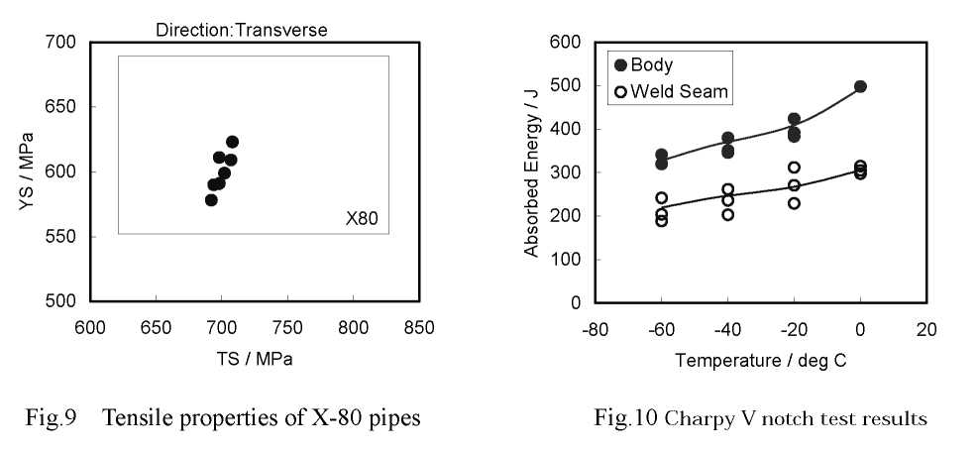
Table 2 showed the result of girth welding test. By limiting the heat input below 12kJ/cm which means good welding efficiency, the girth welded joint had enough tensile strength and fractured in base metal.
Table 2 Girth welding test results
wire heat input | welding | strength of | fracture
(average) | path | weld metal
low H 100ksi 12kJ/cm | 9 | overmatch | base metal
- Discussion
Fig. 11 showed the microstructure of pipe body and seam. The body has fully bainitic ferrite microstructure with no coarse pearlite and martensite. The seam also consists of almost bainitic ferrite and few cementite and martensite. It is thought that very few amount of carbides were dissolved by the heat input because the steel had extremely low carbon content with ensuring X-80 strength.
The strength of the line pipes was ensured. The reason is thought that the microstructure was consists of fully bainitic ferrite phase and few high temperature phase like pearlite or coarse polygonal ferrite were appeared. In addition Nb fine precipitates were dispersed in the bainitic ferrite phase. Fig. 12 showed the TEM micrograph of large amount of fine dispersed precipitates which seams to be effective for precipitation hardening in the pipe body.
The Charpy absorbed energy was greater then 300J. It seems to be also related to the uniform microstructure, that is, coarse secondary phases like pearlite, martensite, which is bad for low temperature toughness, were decreased and thus crack propagation paths were decreased.
6
HOME
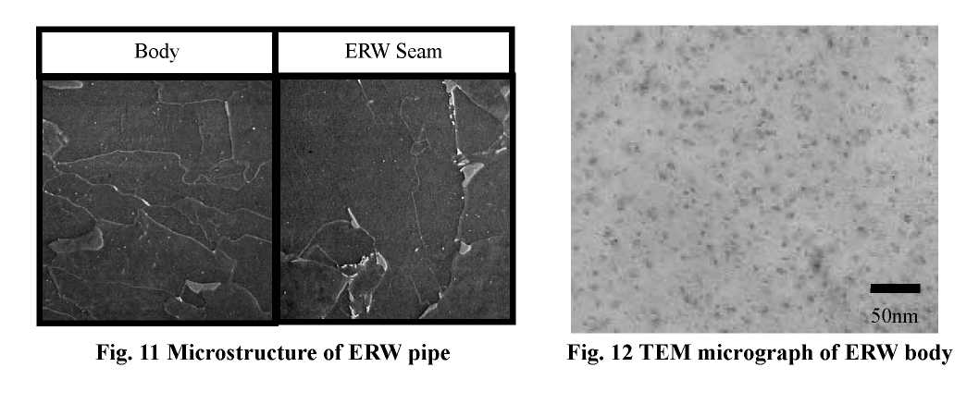

5.Conclusion
- It was achieved that reduction of carbon content to the extremely low level causes excellent low temperature toughness.
- By the application of the new microstructure concept of precipitation hardened bainitic ferrite, the pipes can be produced by hot strip and ERW process. The mechanical properties were in good result.
- It was obtained X-80 grade strength with excellent low temperature toughness of base material and weld. The toughness value of vTrs was below -50degC for each of weld and base material.
- This material also has good weldability for girth welding due to the low Pcm value.
References
- F. Kawabata, K.Amano, O.Tanigawa, T.Hatomura, Y. Sujita, Proc of 11th Int. Conf. on Offshore Mechanics and Arctic Engineering, Vol.V-B(1992),pp.597-603
- E. Sugie, C. Shiga, Y. Nakano, K. Amano, S. Yoshimura, T. Uesugi and M. Kitagawa, 3rd Int. Conf. on Steel Rolling, ISIJ, Sept., 1985
- M.Okatsu, F. Kawabata, K. Amano, Proc. of the 16th Int. Conf. on OMAE Vol.3(1997), pp.119-124
- Y.M.Kim，S.K.Kim，Y.J.Lim，N.J.Kim，ISIJ Int.，Vol.42(12)(2002)，pp.1571-1577
- http://www.abtersteel.com/welded-steel-pipe/erw-steel-pipe/erw-steel-pipe/ ERW PIPES

7
HOME

